Pupil premium strategy statement

This statement details our school’s use of pupil premium funding to help improve the attainment of our disadvantaged pupils.

It outlines our pupil premium strategy, how we intend to spend the funding in this academic year and the effect that last year’s spending of pupil premium had within our school.

School overview
Detail | Data
School name | Meadlands Primary School
Number of pupils in school | 220
Proportion (%) of pupil premium eligible pupils | 16%
Academic year/years that our current pupil premium strategy plan covers (3 year plans are recommended) | 2024-2027
Date this statement was published | December 2025
Date on which it will be reviewed | Autumn 2026
Statement authorised by | Jo Wreford
Pupil premium lead | Laura Barson
Governor / Trustee lead | Penny Frost / Geoff Fisher
Funding overview
Detail | Amount
Pupil premium funding allocation this academic year | £56,479
Pupil premium funding carried forward from previous years (enter £0 if not applicable) | £0
Total budget for this academic year  If your school is an academy in a trust that pools this funding, state the amount available to your school this academic year | PPG - £46,965  PLAC - £7,890  EYFS PPG - £1,624

Part A: Pupil premium strategy plan

Statement of intent
At Meadlands, we believe all children should be encouraged to be ambitious and achieve their best. We believe in opportunity for all, and we are committed to ensuring that each and every child reaches their full potential academically, socially and emotionally. We recognise that PPG provision is central to our whole school approach. The three core strands of our curriculum intent - vocabulary, memory and mental wellbeing – are woven throughout our Pupil Premium strategy, as we know these areas are core to supporting our children.
We recognise that each child entitled to PPG is unique in their situation and has different needs - needs which are varied and complex across the school. Each child also brings their own cultural capital which needs to be valued and enhanced, and the PPG can be used to support this. With this in mind, we have built the capacity and expertise to enable us to provide a personalised programme of support for children and their families, so that each child can reach their full potential. To best understand the needs of our PPG pupils, we assess the intersectionality of need in order to ensure the intended outcomes are based on our knowledge of the pupils.
The data is as follows:
36 pupils PPG
17 (47%) persistent absentee, either this academic year or last academic year
13 (36%) have intersecting SEND needs
5 (14%) have additional mental health needs
23 (64%) are working below ARE
11 (31%) are on the safeguarding register
7 (20%) have additional speech and language needs
6 (17%) have English as an additional language

Challenges

This details the key challenges to achievement that we have identified among our disadvantaged pupils.

Challenge number | Detail of challenge
1 | Attendance data analysis of this academic year and last show that our disadvantaged pupils have lower attendance than their non-disadvantaged peers. Our disadvantaged pupils are also more vulnerable to persistent absence than their peers.
2 | Formative and summative data shows that our disadvantaged pupils may make less progress in core subjects than their peers. This barrier to their reading and writing and phonics is having an impact on the vocabulary gap and impacts life chances of our learners.
3 | Formative and summative assessments and observations show that our disadvantaged pupils are generally more likely to have speech and language difficulties compared to our non-disadvantaged pupils. This is particularly evident for children in EYFS and KS1
4 | SEND data shows that there are a significant portion of our disadvantaged pupils with intersecting SEND needs.
5 | Our mental health data shows that our disadvantaged pupils have intersecting mental health needs. Wellbeing of our pupils is paramount and it is our duty to ensure all pupils are able to feel safe and happy whilst at school.

Intended outcomes
This explains the outcomes we are aiming for by the end of our current strategy plan, and how we will measure whether they have been achieved.
Intended outcome | Success criteria
Disadvantaged pupils to have improved attendance data and those who are vulnerable to persistent absence to be above 90% attendance | - PPG attendance data to be in line with national average  - Staff CPD around attendance and the relationship between attendance and safeguarding  - Positive support in place for disadvantaged families who are struggling with attendance
For the attainment gap between our disadvantage pupils and non-disadvantaged to close in core subjects throughout their Meadlands career by 2027. | - PPG KS1 and KS2 data to be in line with national  - PPG progress data to show accelerated progress  - Pupil and parent voice to show increase in PPG pupil wellbeing and confidence within lessons  - PPG books to show depth of understanding of core subjects
Improvement in children’s expressive and receptive language skills in Reception. Number of PPG pupils who meet expected standard in Communication and Language ELG at the end of Reception by 2027. | - GLD of PPG Reception pupils to increase, with pupils reaching speaking, listening and understanding ELGs.
Pupils with intersecting SEND needs will make accelerated progress against their SEN Support Plans or EHCP Key Stage outcomes. | - Pupils with intersecting SEND needs will be identified early, in order to begin early intervention  - SEND support plans will be co-produced with parents to ensure joined-up thinking with a person centred planning approach.  - Transitions for our pupils to secondary school will be a process rather than an event, and will ensure successful starts in their new settings.
PPG pupils’ mental health will be strong so that they feel safe at Meadlands and are ready to learn. | - Pupil voice surveys will show that PPG children have a positive attitude towards their learning and towards themselves.  - Opportunities for our disadvantaged students to build their self-esteem and self-efficacy skills.  - Reduction in behaviour incidents recorded on CPOMs for those children who are receiving emotional well-being intervention

Activity in this academic year
This details how we intend to spend our pupil premium (and recovery premium funding) this academic year to address the challenges listed above.

Teaching (for example, CPD, recruitment and retention)
Budgeted cost: approx. £25500
Activity | Evidence that supports this approach | Challenge number(s) addressed
Spark Ed Oracy project, linked to whole school oracy project.  This is one year on from project end – still on SDP to ensure high priority for school. Expansion of oracy skills progression map. | “The quality of children’s early language experience has been shown to be a powerful predictor of their subsequent educational achievement across the curriculum, not just in those subjects most closely related to language” (Law et al.,  2017; Roy, Chiatt & Dodd, 2014).  “For many children, school may provide the only opportunities to develop a full, rich repertoire of spoken language skills. This is why many researchers and teachers now believe  oracy education – the explicit teaching of spoken language skills – should constitute a significant part of every child’s educational experience.” (Cambridge University Press & Assessment, 2022)  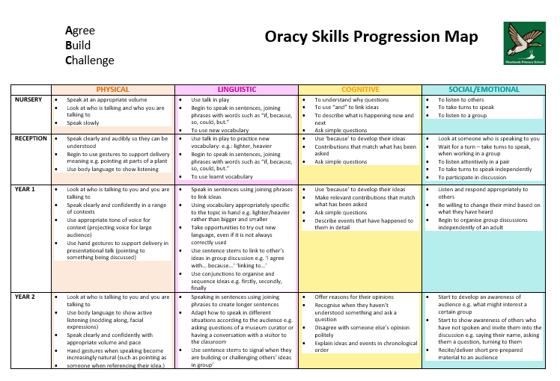 | 2, 3
Early Language Development course, linked to Reception speech and language audits and CPD | “Learning language is the most important thing a child will ever do.” The Communication Trust | 3, 4
Creation of finance curriculum | “Helping children understand and value money from an early age will develop healthy habits around money, in order to manage it well as an adult. On average children begin to receive pocket money aged seven, own their first mobile phone at eight, and purchase items online at ten, with one in five having used their parents’ or older siblings’ credit or debit card to purchase these items.  They can open a bank account and have a debit card at 11. At 18 they can apply for a credit card or loan, and before they leave school, they have to make crucial decisions about jobs, student loans, and living independently.  The need for young people to develop the skills to earn and look after their money has never been stronger.  (Young Enterprise)” Money Heroes | 2, 5
Audit and purchase of Read Write Inc. phonics programme books, for full fidelity to the phonics scheme | “Phonics programmes use programme-specific systems and terminology such as actions, mnemonics, prompts, key words and routines to teach knowledge and skills. It is important not to confuse pupils by mixing material from different programmes or across different classrooms – hence the phrase ‘fidelity to the programme’” 2023 Reading Framework | 2, 3
Mental health lead to teach mindfulness lessons across the school from Nursery – Year 6. | “Mindfulness can help us enjoy life more and pay better attention to the world around us, especially how we interact with it through our bodies.” Anna Freud | 1, 5
Introduction of ‘Focus Few’, pupils for each class, where the teacher in collaboration with the HT and SENDCO will choose a selection of children with intersecting vulnerabilities whose needs they will pay particular attention to when planning and teaching their lessons. | - “The advantage of this strategy is that it uses data as a starting but not a finishing point… It’s not about sitting all the Focus Five pupils in the front row or marking their books first. It’s more nuanced than that, and involves the teacher determining for themselves the most appropriate strategies they will use to support the most vulnerable pupils in their care.”  Greenshaw Research School – Focus Five approach | 2, 4
Vocabulary and root words curriculum created by Headteacher to develop Key Stage two language, support spelling and close language and vocabulary gap | 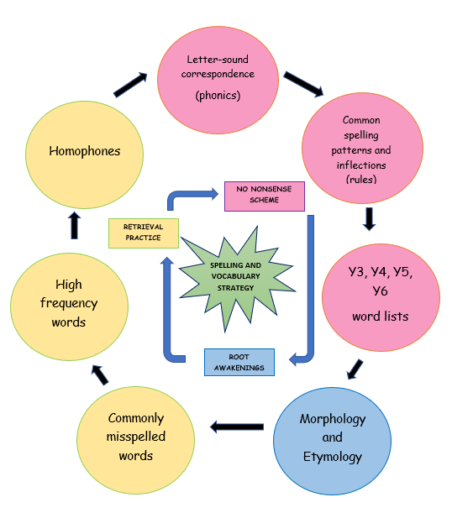  “It was found that by exposing children to etymology and morphology by way of our Root Awakenings programme, there was a positive impact on all learning, vocabulary has broadened, spelling strategies have been enhanced, and children (especially in upper KS2) have gained confidence to use ambitious vocabulary in their independent writing. Children are able to remember spelling patterns better by attaching meaning and a love of language has been cultivated across the school for children and teachers alike, who have embraced the new strategy and extended it across the curriculum. Furthermore, children with SENs have also benefitted as etymology and morphology offers them an alternative method to absorb language.” (Wreford, 2022)  “In short, vocabulary matters; it is a gift that transcends all learning and an instrumental life skill.” (Wreford, 2022) | 2, 3, 4
Educational Psychologist hours used to work 1:1 with specific teachers who are working with complex needs, in order to support teacher wellbeing and promote inclusion. | “Teacher recruitment and retention is currently a significant challenge in England, with schools serving higher levels of disadvantaged pupils facing the biggest challenges.” EEF | 2

Targeted academic support (for example, tutoring, one-to-one support structured interventions)
Budgeted cost: TBC
Activity | Evidence that supports this approach | Challenge number(s) addressed
Educational Psychologist hours increased to work 1:1 on targeted SEND assessment | “Partners should also consider whether and how specialist staff can train the wider workforce so they can better identify need and offer support earlier – for example, educational psychologists” SEND Code of Practice | 4
Speech and language support from Ham Clinic speech therapists, to target specific speech therapy needs within Nursery and Reception classes | “For children who struggle to talk and understand words, their whole lives are affected. Our recent report, Listening to unheard children, found that they are:  - six times more likely to be behind in English at age 11  - eleven times more likely to be behind in maths at age 11  - have more mental health problems  - twice as likely to be unemployed as an adult.” Talking Point.org | 3, 4
Non-class based inclusion TA roles created, to work 1:1 across the school on specific learning interventions.  Creation of this inclusion teams offers bespoke interventions for pupils most in need. | “Inclusion is a continuous process, not an event. It should not be thought of as something ‘to be achieved’.”  Addressing Educational Disadvantage. Marc Rowland. 2021 (Woodbridge) p35 | 2, 3, 4
British Dyslexia Assessments funded by school for specific pupils with intersecting needs | “A dyslexia assessment will provide a clearer picture of someone's cognitive profile and their strengths and challenges. This will help to ensure that any support put in place is as effective as possible.” British Dyslexia Association | 3, 4
Purchase of Wellcomm programme to screen all Early Years and KS1 pupils with speech and language concerns, to provide diagnostic support and targets. | “It’s clear that most teachers in both primary and secondary schools think that a significant proportion of students have speech and language barriers, that the numbers have grown in the past five years”  'Lost for Words' report
Educational Psychologist hours increased to create package of TA CPD | “Leaders and teachers discussed key skills and characteristics that make TAs effective in their role. This includes their personal attributes and training and qualifications.” 'Use of teaching assistants in schools' - DfE report | 2, 3
Use of AfC credits to receive training from Early Years borough advisor. Specific training for Early Years team and Senior Leaders about high quality interactions and the ShREC approach in Early Years. | “Supporting children to become better communicators is one of the most powerful things we do as early years educators. Oral language skills are fundamental to children’s learning, thinking and emotional wellbeing. Children who can communicate well can make friends, play, resolve conflicts and tell us how they are feeling.”  Shuey and Kankaraš, 2018 | 3, 4

Wider strategies (for example, related to attendance, behaviour, wellbeing)
Budgeted cost: £12,000
Activity | Evidence that supports this approach | Challenge number(s) addressed
Employee Assist programme for all staff mental health and wellbeing and attendance | “Despite the recognition that teachers are essential to their students’ learning and that teaching is one of the most stressful professions, there has been a lack of attention paid to teacher well-being and meaningful government action remains limited.” Education International Global report | 2
Spark Ed project – Addressing Educational Disadvantage | “It is important to relentlessly focus on the impact of disadvantage on learning. Some issues pupils face may be beyond the school’s power to change. But it is possible to address the impact these issues have on learning, as well as pupils’ sense of belonging at school and in the classroom.”  Disadvantage - Widening the lens | 2
Virtual School’s Attachment Aware Gold Award to ensure the wellbeing of all disadvantaged pupils is being supported by school staff and wider stakeholders | “AfC Virtual School is working with schools across Achieving for Children in collaboration with EPS in both Operational Areas to deliver the Attachment Aware Schools Award. Our approach is based on research from Bath Spa University, the REES Centre and successful Attachment Aware Schools Award projects in other authorities.” AFC Virtual School | 1, 5
Creation of Family Support Worker role. FSW to be in school 1x day per week working 1:1 with families. Support including home visits, liaison with CAMHS, SEND coffee mornings, charity signposts and parenting support. | Case study of two pupils who worked alongside FSW, both with improved attendance and punctuality after 3 months. | 1, 5
‘The Retreat’ wellbeing space created to support the behaviour and wellbeing of the school’s most vulnerable pupils from years Reception – 6, 5x weekly, every afternoon. | “We cannot fast track children who have experience trauma and loss into emotional and sensory literacy, without first giving them the opportunity to fully negotiate the developmental stage of dependency.” Louise Bomber ‘Inside I’m Hurting’, p10  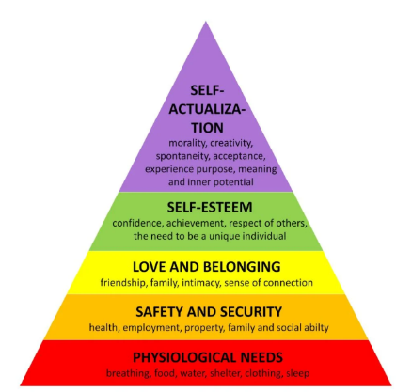  Maslow | 1, 4, 5
Attachment Aware School –now on Achieving for Children’s Virtual Schools Platinum Board.  Sharing good practice of trauma informed practice across other schools | 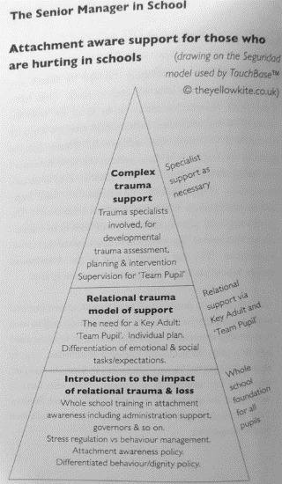 | 5
Smartphone free Meadlands events run in collaboration with parent led smartphone free Meadlands parent groups, in order to bring awareness to link between screen time and mental health, empowering parents to navigate smart phones with their children Disconnect to Reconnect | “Tech companies intentionally make apps addictive because the more time we spend, the more data they harvest, the more money they make. By leveraging dopamine circuits, they trigger brain responses akin to slot machine gambling. 1 in 4 young adults show signs of behavioural addiction to smartphones.” Kings College London | 1, 5
Brite Boxes offered to most vulnerable families, to offer weekly opportunities to cook together | “74.1% said BRITE Box helps them with their food budget. The three issues most mentioned in the parents’ interviews were:  -Trying new foods  -Bringing the family together  -The impact BRITE Box had on family finances, food security, and food budgeting.” Voices of Hope Impact Report | 5
Headteacher and Deputy Headteacher created Inclusion Plan - mapping out all opportunities for inclusion across the school, in line with Inclusion Charter and toolkit | 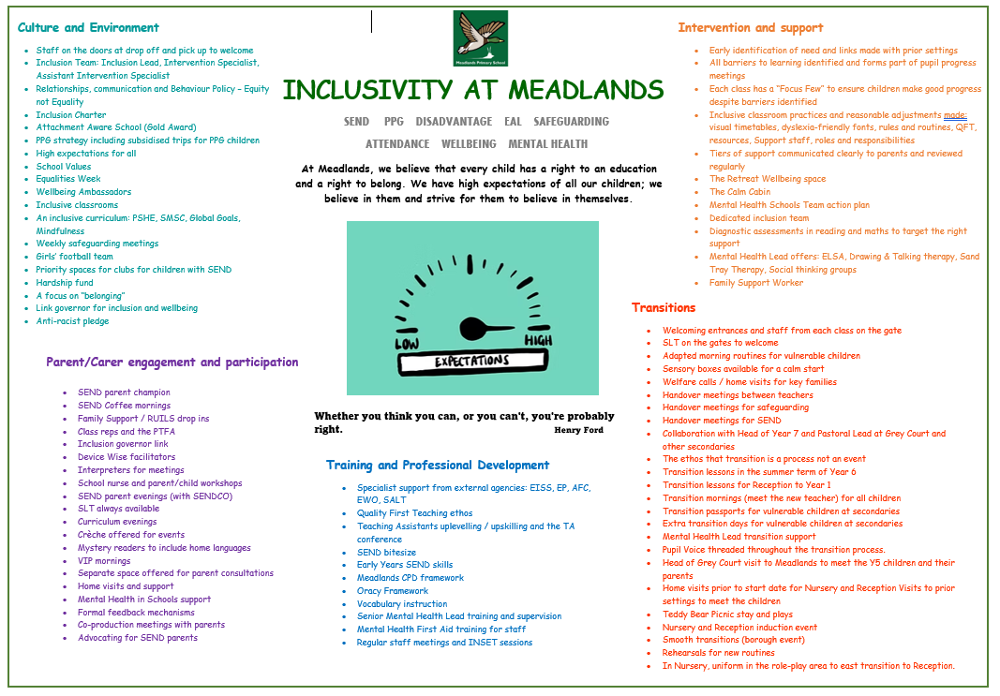 | 5
Priority clubs spaces and free clubs spaces offered to pupils with intersecting needs | “Arts participation approaches can have a positive impact on academic outcomes in other areas of the curriculum” EEF menu of approaches evidence brief | 1, 5
Spark Ed project – Practical Approaches To Support Behaviour Management  Attended by Headteacher, Deputy Headteacher and KS2 teacher | “The consistent and fair implementation of the measures outlined in the behaviour policy is central to an effective whole-school approach to behaviour. Consistent implementation helps to create a predictable environment. Some pupils may require additional support to meet a school’s behaviour expectations. This support should be given consistently and predictably, applied fairly and only where necessary.”  Behaviour in Schools - Ofsted 2024
SEND coffee mornings run by SENDCO in collaboration with SEND parent champion to signpost parents to local charities and support. | “The SEND Code of Practice makes it clear that parents must play a central role in discussions and decisions regarding the provision made for their children.” NASEN | 1, 4, 5
Mental Health in Schools Team working with Mental Health lead to develop robust mental health and wellbeing offer. | “Services are geared for more severe mental health, meaning there is a paradox where children have to get worse before they meet threshold for treatment. The aim of the programme is to catch difficulties at a much lower level before the escalate.” MHST | 1, 5

Total budgeted cost: TBC

Part B: Review of outcomes in the previous academic year

Pupil premium strategy outcomes
This details the impact that our pupil premium activity had on pupils in the 2024 - 2025 academic year.
Results:
An analysis of our school’s disadvantaged pupils during 2024-2025, drawing on national assessment data and our own summative assessments shows that:

KS2 results for 2024-2025 show that of our 9 PPG pupils, 7 achieved the expected standard or above in reading, 7 in writing and 8 in maths. Those who did not achieve the expected standard in RWM had intersecting SEND needs.

Year 1 Phonics screening results show that of 3 of our 5 PPG pupils who sat the Year 1 phonics screening passed the test.

Attendance:
PPG pupils’ attendance last year was below the national average, and the majority of Meadlands’ persistent absentees were PPG.
The link between attendance and safeguarding has been highlighted during staff training, as well as meetings with other stakeholders, such as Governors. Attendance is a standing item on all meeting agendas.
Attendance is a lead priority for the upcoming years’ School Development Plan.

Behaviour:
The introduction of our wellbeing space – The Retreat – reduced the number of behaviour incidents for our disadvantaged pupils. Exclusions reduced from 10 in 2023-2024 to 0 in 2024-2025.

Wellbeing:
There was large investment in the training and ongoing CPD of our mental health lead last academic year. This is now being disseminated through the introduction of specific therapies such as drawing and talking, and whole school mindfulness lessons for the year 2024.

Overall, attendance and trauma informed practice need to be the key drivers of our upcoming strategy, due to the links between safeguarding, attendance and disadvantage in our pupils.

Externally provided programmes
Please include the names of any non-DfE programmes that you purchased in the previous academic year. This will help the Department for Education identify which ones are popular in England
Programme | Provider

Service pupil premium funding (optional)
For schools that receive this funding, you may wish to provide the following information:
Measure | Details
How did you spend your service pupil premium allocation last academic year? | N/A
What was the impact of that spending on service pupil premium eligible pupils? | N/A

Further information (optional)

