
Reception Parent Curriculum Booklet
2025 - 2026

Our school vision:
At Meadlands we dream big. Our mantra is borrowed from our literary hero, Roald Dahl: “We are the music makers and we are the dreamers of dreams”. And our motto is ‘Work Hard & Be Kind’.

What do these words mean to a kid like me at Meadlands? It means we learn more than just facts and subjects, we are taught how to learn so we can be adaptable and be ready for the world we will be part of when we are older. Meadlands encourages us to be self-motivated, to use our own initiative, to be resilient, curious, imaginative, determined and above all else to be kind and respectful. My teachers and staff know me very well, my learning is personalised to my own strengths and weaknesses, I have goals set to challenge me, to break down my barriers and overcome my difficulties. So I can always be better and do better. As a class we make outstanding progress in our lessons. We are proud of ourselves and each other. As a school we all work to improve and grow it. Students, parents, care givers, staff, leaders and governors. Everyone is invited to contribute. This is part of our experience.

Our school is committed to dreaming big. Never resting on our laurels. The curriculum is always developing and improving, delivering the new skills and knowledge we will need for the future. Our school is a harmonious place to be, where we know through hard work and kindness, every dream is possible.

Mrs Wreford and Mrs Taunton-Johnson

Welcome to the Atlantic Puffin Class! I am very excited to be teaching Reception this year and eager to get to know all the new faces of Puffin Class better. I want to provide the best learning opportunities for all children and hope we can have lots of fun on the way. It is my privilege to be able to support the children through this big step in their lives and I look forward to see the progress they make as they face new challenges. We will be supported by the Early Years Support team. We work as a united front and are all enthusiastic for the year ahead. If you have any questions at all then please feel free to grab me for a chat on the gate or contact me at: a.cooper@meadlands.richmond.sch.uk.
Miss Cooper

Reception team
Miss Annie Cooper – Class Teacher (CT) | Early Years Support Team
The Senior Leadership Team
Co-Headteachers: Mrs Wreford and Mrs Taunton-Johnson
Designated Safeguarding Lead: Mrs Wreford
Deputy Headteacher/Inclusion Lead / SENDCO: Mrs Barson
School Business Manager and Deputy Designated Safeguarding Lead: Mrs Jolene Gee
Support Staff and Deputy Designated Safeguarding Lead: Mrs Sue Kelly

For a full list of roles and responsibilities please see the school website.

Office hours and contacting school
- Messages: For non-urgent messages and questions please continue to email the office (office@meadlands.richmond.sch.uk) or Miss Cooper (a.cooper@meadlands.richmond.sch.uk ) or call the office (0208 940 9207).
- The office is open between the hours of 9am – 9.10am and 3.20pm – 3.45pm.
- Dropping off equipment: Please continue to use the delivery box at the front of the school.
- As well as calling the school office before 9.00am please note that you can use the Parentmail app to report absence following our communication policy.
- In line with promoting staff’s wellbeing and helping staff to find a suitable work-life balance, staff will respond to communication within 48 hours/2 working days of its receipt and will respond during their working hours. Parents are politely asked not to chase a response within a 48-hr period or seek a response from another member of staff.
- Staff will respond to communication during of their working school-based hours. Please note that if you email during the school holidays, you may only receive a response on the first day back at school.

If you have questions about any of the topics in the table below, or would like to speak to a member of staff please email the relevant staff member:

Query | Who | When and How
General | Co-Headteachers  Mrs Wreford  Mrs Taunton-Johnson (Mon-Wed) | j.wreford@meadlands.richmond.sch.uk  s.taunton@meadlands.richmond.sch.uk
Absence  Trips  Clubs and Events  Medicine  Uniform  Meals | School office | In person: 9.00am and 9.10am and 3.20pm and 3.45pm.  Phoning the school office on 020 8940 9207  office@meadlands.richmond.sch.uk
Questions or queries that relate to teaching, learning, homework and boosters  Pastoral concerns - these need to go through the class teacher  Behavioural concerns  General concerns or queries | Teaching Staff | Request an appointment by emailing  Nursery: j.nicholas@meadlands.richmond.sch.uk  Reception: a.cooper@meadlands.richmond.sch.uk  Year 1: j.clark@meadlands.richmond.sch.uk  Year 2: j.hepburn@meadlands.richmond.sch.uk  Year 3: j.edwards@meadlands.richmond.sch.uk  Year 4: e.halberstadt@meadlands.richmond.sch.uk  Year 5: m.warner@meadlands.richmond.sch.uk  Year 6 h.stoddart@meadlands.richmond.sch.uk  or have an informal chat after school
Finance, payments or admissions | School Business Manager  Mrs Gee | Phoning the school office on 020 8940 9207  j.gee@meadlands.richmond.sch.uk
Safeguarding | Designated Safeguarding Lead  Deputy Designated Safeguarding Lead  Deputy Designated Safeguarding Lead | j.wreford@meadlands.richmond.sch.uk  j.gee@meadlands.richmond.sch.uk  s.kelly@meadlands.richmond.sch.uk
Query relating to SEN needs | Special Needs Coordinator  Mrs Barson | l.tadman@meadlands.richmond.sch.uk
If there has been an unsatisfactory outcome to your enquiry | Senior Leadership Team | office@meadlands.richmond.sch.uk
Governing Board | Chair of Governors | chairgb@meadlands.richmond.sch.uk

Clubs
The clubs’ newsletter is typically circulated two weeks before bookings open. All bookings unless otherwise stated on the newsletter can be booked through the "shop" on Parentmail. The window for bookings will be detailed on the newsletter and places will be allocated on a first come, first served basis.
- Clubs are ten weeks unless otherwise indicated.
- On their club day and when it is not a PE day, children need to come to school in their school uniform and can then change into their club clothing afterschool.
- We have a year round, all weather policy for our outdoor clubs, meaning come rain or shine we will try our hardest to run the club. However, there will be occasions when clubs do have to get cancelled and we will aim to provide parents and carers will as much forewarning as possible.
- For clubs run outside on the field, basketball court in the MUGA, these clubs will go ahead as long as the pitch and playing conditions are safe. However, if the weather takes a turn for the worst during the club and the playing conditions become unsafe, then the club will continue inside.
- To view our Clubs page, please see the school website.

First Aid
Clubs run by staff will have a Meadlands staff named first aider.

Attendance and punctuality
- Lessons start at 8.55am prompt. The gate opens in the morning from 8.45am and will be locked at 8.52am. Registration and the start of the school day starts at 8.55am. If your child arrives after 8.55am, they will be marked down as late.
- If the gate is closed when you arrive, please enter via the Office and electronically sign your child in.

- Our attendance target is 96.5% or above; both Mrs Frank and Mrs Taunton-Johnson closely monitor attendance. We consider attendance to be an essential part of daily school life, in line with our high standards and expectations for learning. Attendance is reviewed on a Monday. If we are concerned about your child’s attendance or punctuality, you will be invited in to meet with Mrs Taunton-Johnson..
- Each week the class with the highest attendance wins the attendance trophy.
- Request for absence forms can be collected from Mrs Frank in the school office. Please note all medical absence will be authorised. However, evidence may be requested if your child’s attendance has dropped below the statutory baseline of 90%. Please be aware, we are not permitted to authorise any holiday during term time and therefore we ask any parents who are considering this to speak with Mrs Taunton-Johnson or Mrs Wreford in advance of considering booking a holiday.
- Further information on attendance and punctuality can be found on the school website.

PE Days and Uniform
In Reception, children will have PE on a Friday.
You will be informed through the school’s newsletter of the PE days for each new half-term. On PE days, children need to come to school in their PE kit and their trainers.

School Lunch and Birthday Celebrations
School Dinners
School dinners are now free for every child who would like one. Due to the ordering and level of administration involved, dinners must be ordered for the full week and not specific days and we ask that you only switch between packed lunches and school dinners on a half-termly or termly basis. The school menu can be viewed on the school website.

Packed Lunch
We encourage a healthy approach to packed lunches, crisps (fried potato crisps), chocolate (bars, coated biscuits, cakes and chocolate spread), fizzy drinks, fruit shoot drinks and sweet sandwiches are not allowed in packed lunches. Instead please look for healthier alternatives, such as baked crisp, rice cakes, popcorns, crackers, plain fruit or vanilla sponge cake, cereal bars and savoury sandwiches only.
Policy encourages that every packed lunch should have at least 1 potion or fruit and vegetable.
Friday is known as treat Friday in school, which includes the Friday biscuit sale (see below). We permit a treat option in packed lunches such as a slice of chocolate cake or a favourite packet of crisps. Please note that sweets and chocolate bars will not be permitted even on treat Friday.

Nut and Seed Free School
Please note that Meadlands is a nut and seed free school. We ask that ingredients on packets are checked carefully and food items ‘that may contain nuts’ are not brought into Meadlands, this also include in packed lunches for trips.

Water for all
Please make sure that your child brings in a labelled water bottle with them. Cold water is available in school. We ask that water bottles are taken home at the end of the day to be cleaned.

Playtime Snacks
Early Years are given a piece of fruit each morning at snack time. Children are welcome to bring in their own snack if they want. This should be a piece of fruit and not fruit substitutes such as fruit bars. Early Years are also given a carton of milk each day until they are 4. When the children turn 5, they are able to pay for milk from the office.
Friday is known as treat Friday at school and on this day, children whose parents have paid online will receive 2 biscuits.

Birthdays
We are happy that we are able to continue the tradition of sharing a birthday with class friends. However, parents are asked to purchase or make individual cakes. If 1 big cake is brought into school we will not be able to cut it up and will instead send it home. If you would prefer your child did not receive this, please inform the class teacher.

Healthier birthday treats, such as fruit kebabs are also welcomed. WE DO NOT PERMIT PACKETS OF SWEETS TO BE HANDED OUT AS A BIRTHDAY TREAT. The option will be cake or fruit. We do not wish to upset any child on their birthday, so please do not send in confectionary as an option, it will be sent home.

Playtime
We are a one-form entry school with a large expanse of playground space, which means children get to choose a wide range of activities in their playtime from basketball, football to dressing up. This also means playtime is for everyone and children from Reception to Year 6 play together in the big playground. We complete regular risk assessments of playtime and equipment; completed by members of the SLT, Governing body and external companies. All of our support staff are First Aid trained.
Medical
Parents are requested to complete Medical forms annually and to keep the office updated of any medical changes. If your child is diagnosed with a chronic long-term medical condition, then please make an appointment to meet with either Mrs Taunton-Johnson or Mrs Wreford. With any case of a long-term medical condition or chronic illness an Individual Healthcare Plan (IHP) will need to be created. Examples of medical conditions that would require an IHP are: food allergies that require the use of an Epi-pen, asthma, febrile convulsions, diabetes and epilepsy.

If children have medicine, a form must be completed which gives permission to the school to administer medicine. Medicine must be handed to staff on the gate and not kept in the child’s bag. We are permitted to give Calpol, but will always seek parental permission before doing so.

Term Dates
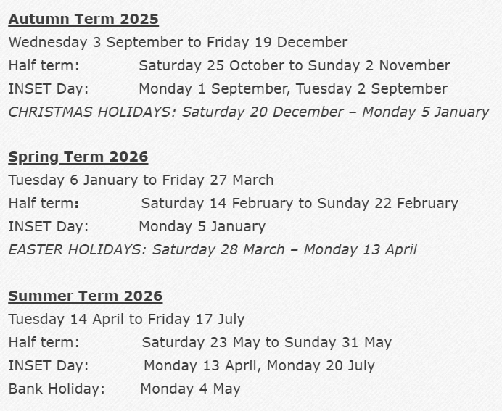

Reception Curriculum Overview
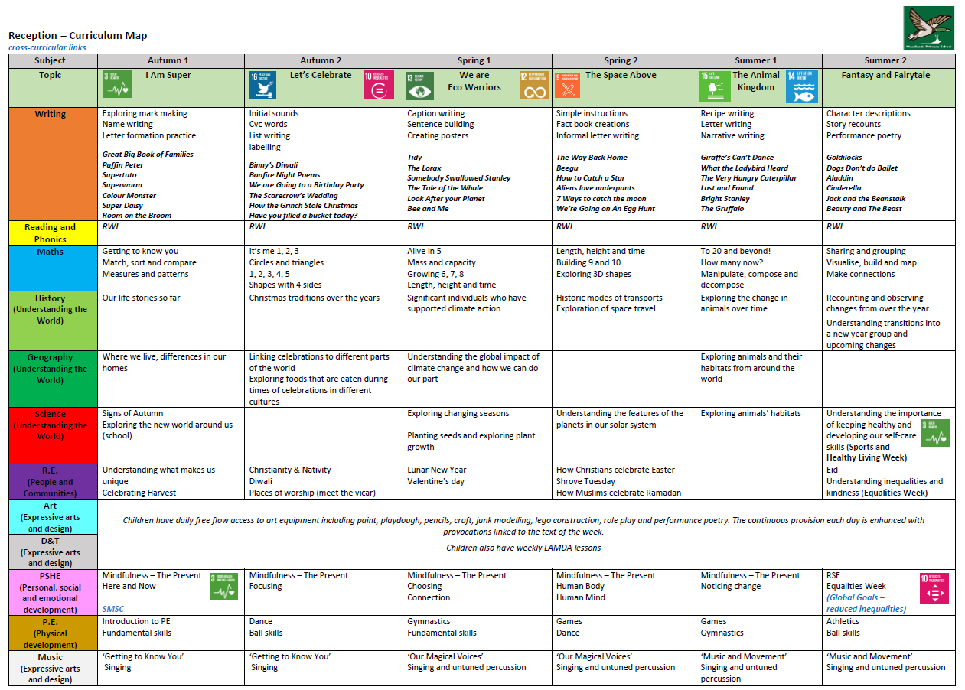

Weekly sample timetable
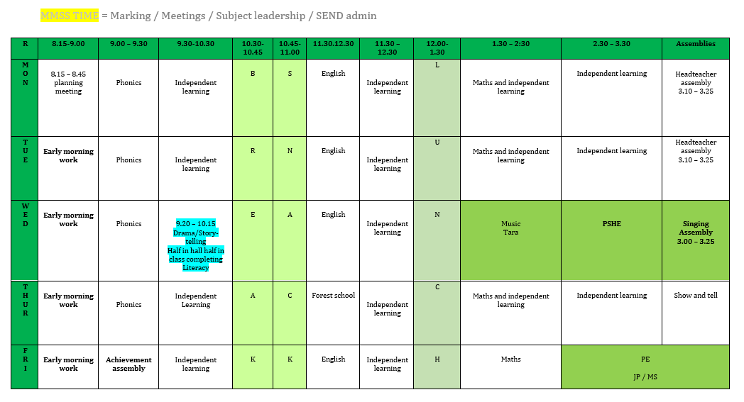

Class Trips
We are hopeful that Reception will have a class trip or an in-school visit/workshop every term. The trips booked will enhance the curriculum and provide opportunities for children to develop their knowledge and skills around a specific topic.
If you would like to volunteer as a parent helper on trips, please read and sign the Meadlands School Visits Volunteer Agreement Form at the end of this pack and pass to the office. We always need help on school trips so extra parent volunteers are hugely appreciated, thank you.
Half-Term/ Date | Event | Approximate Cost
Autumn | Christmas workshop St. Andrews | Free
Spring | Ham Library | Free
Summer | Visit to the swings | Free

- *Please note these are provisional trips and have not yet been booked/confirmed.
- Parents will be notified by letter in advance of each trip, and it is possible that trips/costs may be changed or added, although we will try to stick to these possible.
- If you need financial support for any of the trips please speak directly to Mrs Gee j.gee@meadlands.richmond.sch.uk

Parents Evening
Early Years run parent meetings differently, due to our different assessment cycle. The meetings are called ‘Spotlights’ and they happen twice per year, based on your child’s birthday. Please see the timetable below to understand when your child’s spotlights will be e.g. a child with a January birthday will have a spotlight in Jan and then again in July. This means that the teacher will get in contact with you to arrange a meeting during those months. These meetings will still be 10 mins long and will replace the parent’s evenings that the rest of the school have.

Birthday  Month | Jan | Feb | Mar | Apr | May | June | July | Aug | Sept | Oct | Nov | Dec
Spotlight | Jan | Feb | Sept | Oct | Nov | Dec | Jan | Feb | Sept | Oct | Nov | Dec
Spotlight | July | July | Mar | April | May | June | July | July | Mar | April | May | June
*Please note that due to baselines happening at the start of the year in Sept, your initial meeting may be at the start of Oct.

Curriculum Events Calendar (these dates are subject to change and confirmed dates and events will be shared in the Mallard Messenger)

PTA Events – these events will be shared in the Mallard Messenger
Thursday 18th September | Meet the Teacher and welcome BBQ
Saturday 6th December | Christmas Fair
Saturday 11th July | Summer Fair

Parent Book Looks: 3.30 – 4pm
18th September (at Meet the Teacher)
21st /22nd October (at Parent Evenings)
12th December
10th/12th February (at Parent evenings)
1st May
26th June

Statutory Assessment Information Session for Parents:
KS2 SATs information evening | Wednesday 26th November 2025, 5:30pm – 6:30pm
SAT week KS2 | Monday 11th – Thursday 14th May 2026
Year 4 Multiplication Test Check | 2 weeks from Monday 1st June
Year 1 Phonics information evening | Thursday 5th Feb 2026, 2.30 – 3.30pm
Phonics Screening Check | Week of 8th June 2026

Curriculum Events (exact dates and times to be confirmed):
Autumn 2 | Maths Curriculum Evening
Spring 1 | Reading Curriculum Evening

Class Assemblies:
23rd January 2026 | Year 5 assembly & bake sale
6th Feb 2026 | Year 4 assembly & bake sale
20th March 2026 | Year 3 assembly & bake sale
1st May 2026 | Year 2 assembly & bake sale
22nd May 2026 | Year 1 assembly & bake sale
12th June 2026 | Reception assembly & bake sale
3rd July 2026 | Nursery assembly & bake sale
Tues 14th and Wed 15th July | Year 6 Show

Special Whole School Assemblies /Productions:
EYFS and KS1 Nativity | Tuesday 16th December (morning)
EYFS and KS1 Nativity | Thursday 18th December (afternoon)
KS2 Christmas Carol concert at St Andrew’s church (evening performance) | Tuesday 16th December
Christmas lunch | Wednesday 18th December
Arts Extravagnza (Music and LAMDA performances) | Thursday 19th March
Easter Assembly (bonnet parade) for EYFS parents | Thursday 26th March
Family Day Assembly and picnic | Friday 19th June 2.00 – 3.30pm
Year 6 Production – evening performances | Tuesday 14th and Wed 15th July
Year 6 trip to Chessington  Year 6 bowling | Friday 16th May  Friday 18th July (to be confirmed)
Year 6 Farewell Assembly | Friday 17th July 9am

Enrichment Days/Weeks:
Disconnect to Reconnect | Monday 3rd November to Friday 7th November
Kindness Week | Week starting the 15th December
KS2 Spelling Bee | Thursday 5th Feb
KS1 Spelling Bee | Thursday 25th June
Poetry Slam Launch | Monday 9th Feb
Poetry Slam | Friday 6th March
World Book Day | Thursday 5th March
Shakespeare Fortnight | Starting Monday 16th March to 26th March

Active Travel Events:
Junior Citizen year 6: | Tuesday 10th March 2026
Safe walking year 3: | Monday 9th March 2026
Year 6 bike ability: | Monday 1st June to Friday 5th June 2026
Year 2 safe scooting: | Friday 24th April 2026

Non-Uniform Days
We publicise Non-uniform Days in our weekly newsletter and on the school website. Non-uniform Days are often an exchange for a £1 contribution towards a charity, or a PTA event. We support national charities such as Save the Children (Christmas Jumper Non-uniform Days) and Comic Relief (crazy hair day) but on occasion we are also asked to support local charities.
Each year the children vote on which charity they would like to support. This will be confirmed by the end of September.
In addition to this the children have ‘Non-uniform Days’ on other occasions such as Grounds Day when they should come to school in outdoor clothing or dress up day linked to a curriculum event.

Curriculum Targets
At the beginning of each year, the children are set academic targets in Reading, Writing, Maths and Science. These are set by the SLT and class teacher and are based on previous outcomes and projected attainment. The SLT and class teachers meet at least termly to discuss the progress each individual child is making towards their end of year target and it is during this discussion that extra support, such as boosters, is decided upon.

Reception Key spelling words:
Alongside daily phonics sessions which will focus on developing children’s creativity through applying their writing to a number of genres, there will also be a focus on not just new spelling rules, but a continued development of phonics and key spelling words.
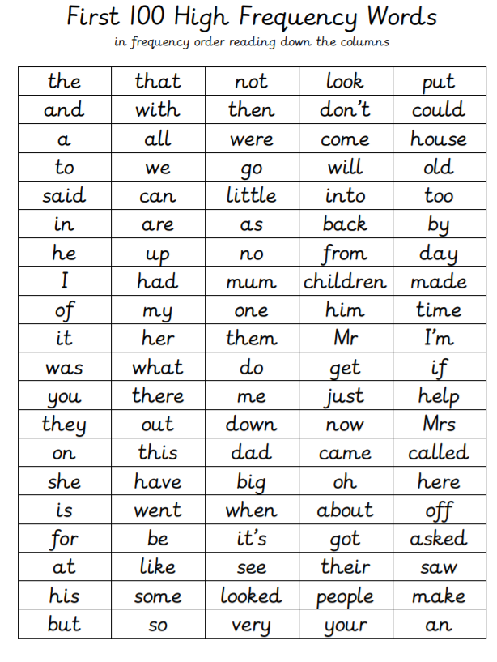
It is the expectation that by the end of Reception, pupils will have demonstrated that they are able to read and spell at least 50% of the following words correctly.

Reading at home
Although we do not set homework in Reception, we encourage you to have lots of discussion with your child and read lots of stories to promote discussion. After we have learnt all of our set 1 sounds in phonics we will be sending books home for you to read with your child. A book will go home once a week alongside a reading record where the parent should record the reading. Children will also be read with once a week with a teacher who will also record this in the reading diary.
Example reading discussion questions to support reading at home
It is not necessary to ask every question each time your child reads, of course, but they may prove to be useful prompts to start a more focused discussion.
- What has happened in the story so far?
- What do you think will happen next?
- Who is your favourite character? Why?
- Why might the character be doing what they are doing?
- Who is the character you like least? Why?
- If you met one of the characters from the story, what would you say to him / her?
- Which part of the story is your favourite / least favourite? Why?
- Which part of the story was the funniest/scariest/ saddest/ happiest?
- Is this an information book or a story book?
- Did this book make you laugh? Can you explain what was funny and why?

Of course, it doesn’t have to be you asking the questions. Why not turn the tables and let your child ask you about your reading material? The greatest encouragement for your child is to see you - their most influential role model - reading.

Meadlands Assessment
This year we are continuing with our new system for meeting with parents. This will not be in line with the rest of the school, but instead we will be meeting with you based on your child’s age and stage. We feel that this puts the child at the centre of the meeting and to help discuss meaningful milestones based on their age.
Here is some information about the assessment tool we are using – OP&L
Milestones
Opal works on the basis of having very simple, six-monthly child developmental milestones, which we use to monitor children’s development. When looking at the statements, we assess if the child has met the milestones and record a simple ‘yes’ or ‘not yet’. We know that not all children will have ‘typical’ development. OP&L allows us to tell and celebrate each child’s story and focus on the support they need from us.

Starting points
Not long after a child joins us, we complete a ‘Starting Points’ assessment, looking at the milestones the child has just passed. For example, if a child joins us at 39 months, we would look at the milestones for 36 months. This helps us to quickly identify children who are not reaching milestones and may need more support.

Spotlights
The observations and assessments that we make are called ‘spotlights’. We observe children’s innovation, their creativity, their ideas, their intents and feelings. The insight that we gain enables us to discuss, reflect and plan our environment to support and shape future learning. We don’t want to plan a next step to tick a statement off a list. We want to plan learning that will be meaningful and memorable for that child.

As children reach their milestones at different points in the year ‘spotlights’ are spread out, making it fairer for the child as they are being assessed against the age-related milestones that they have reached, not a best fit judgement in a wide age-band. We want to shift the focus to the child, not the assessment. The assessment is a quick look at whether a child is meeting their age-related milestones and if not, having discussions, thinking about why and planning what to do. When children are meeting milestones, we can think about their individual development holistically, thinking about what we can do to inspire and challenge them further.

If there are children who are not making progress due to social and emotional needs they may be given ELSA support on referral only by Meadlands staff and parental consent will be gained before any ELSA sessions commence. For some of our children who have additional needs they may be working with different milestones to their peer group. These children are often supported by a Learning Support Assistant and guided by our SENDCo.

