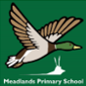

ORACY FRAMEWORK
Introduction
Oracy, the ability to communicate effectively through spoken language, is crucial in schools because it lays the foundation for learning, boosts confidence, and enhances academic and social-emotional development. Strong oracy skills are linked to improved literacy, critical thinking, and overall academic achievement. Furthermore, oracy empowers students to participate actively in their learning, express themselves clearly, and build positive relationships.
Establishing a school-wide Oracy framework to empower children with effective verbal expression is a key curriculum principle at Meadlands. We link verbal expression to the explicit teaching of vocabulary. Within this is the instruction of Latin and Greek root words which raises word consciousness, fosters a love of language and equips our children with the tools necessary to be able to articulate their thoughts and ideas.
The importance of Oracy has been included in every subject policy.
Oracy principles
- High expectations for Oracy (Standard 2)
Do not accept under-developed answers
Use of precise and key vocabulary
Meaningful talk (exploratory talk)

- Value every voice (Standard 5)
Listen meaningfully to each child
Lollipop sticks (cold-calling) in its place to ensure all children participate
Recognition for participation and targeted feedback

- Explicit Oracy teaching opportunities (Standard 3, 7)
Oracy included in every subject policy
Opportunities for Exploratory and presentational talk
Agree, Build, Challenge as a whole school approach
Say it again, better (vocabulary and grammar focus)
Thinking time
Discussion guidelines
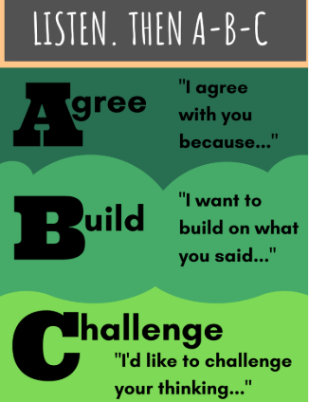
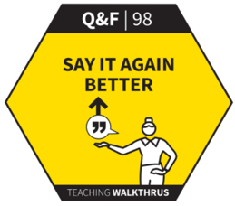
Oracy strategies
Agree, Build, Challenge
Say it again, better
Exploratory talk
Presentational talk

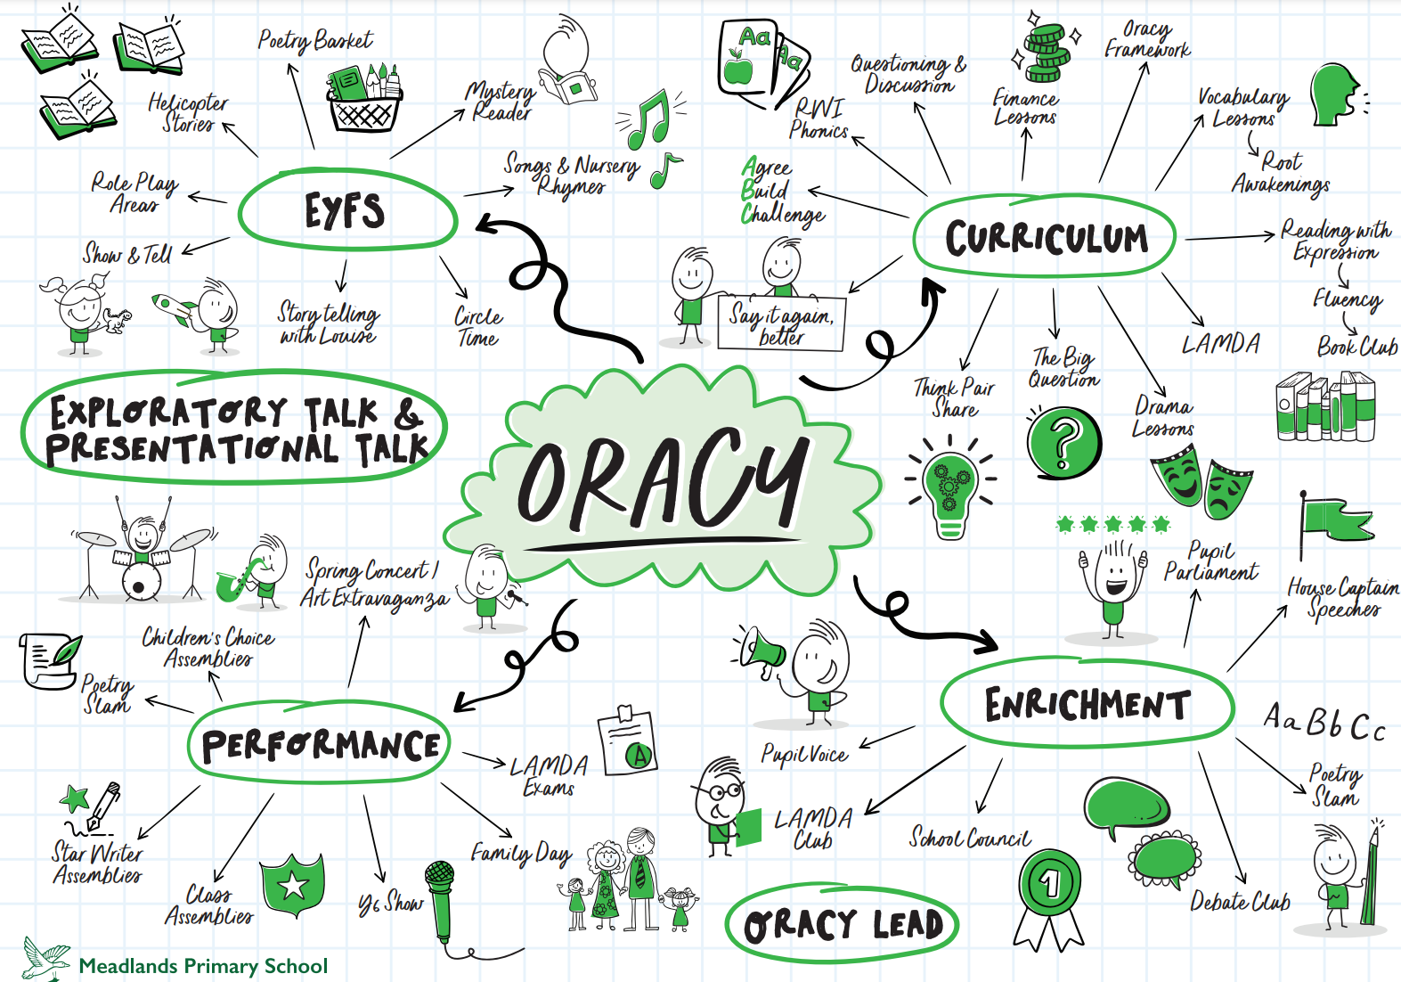
Oracy opportunities mapped across school life

Oracy Assessment Framework
At Meadlands, the Voice 21 oracy assessment framework will be used which is broken down per key stage and displayed in every classroom. Children in Upper KS2 are encouraged to self-assess against this. This framework breaks Oracy down into 4 key areas: Physical, Linguistic, Cognitive and Social and Emotional This allows teachers to be able to pinpoint areas of weakness and focus on these.



