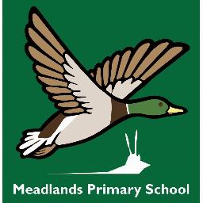

History Policy

Status | Non - statutory
Review cycle | Every 2 years
Date written/last reviewed | April 2025
Date of next review | April 2027
Signature of Co-Headteacher  Mrs Wreford | 
Date | April 2025
Signature of Chair of Governors  Annabelle Hughes | 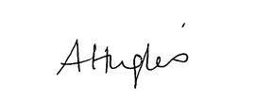

At Meadlands we dream big. Our mantra is borrowed from our literary hero, Roald Dahl we are the music makers and we are the dreamers of dreams. And our motto is Work Hard & Be Kind. What do these words mean to a kid like me at Meadlands? It means we learn more than just facts and subjects, we are taught how to learn so we can be adaptable and be ready for the world we will be part of when we are older. Meadlands encourages us to be self-motivated, to use our own initiative, to be resilient, curious, imaginative, determined and above all else to be kind and respectful. My teachers and staff know me very well, my learning is personalised to my own strengths and weaknesses, I have goals set to challenge me, to break down my barriers and overcome my difficulties. So I can always be better and do better. As a class we make outstanding progress in our lessons. We are proud of ourselves and each other. As a school we all work to improve and grow it. Students, parents, care givers, staff, leaders and governors. Everyone is invited to contribute. This is part of our experience.
Our school is committed to dreaming big. Never resting on our laurels. The curriculum is always developing and improving. Delivering the new skills and knowledge we will need for the future. Our school is a harmonious place to be. Where dreaming is nurtured. Where we know through hard work and kindness, every dream is possible.

INTENT
‘The study of the past is a puzzle that leads to a greater understanding of our world. The study of characters from the past, their decision-making and the impact of those decisions upon our lives can be seen as the crux of what history is.’
Doull, Russell, Hayes, 2019

At Meadlands, we understand that history is all around us. By studying the past, we inspire curiosity, critical thinking and analysis. History encourages debate and investigation; it develops our empathy. The skills we derive from studying history are transferable and influence our own lives. The intent of our History curriculum is to deliver a curriculum which is accessible to all and that will maximise the outcomes for every child so that they know more, remember more and understand more.

‘Ultimately, there’s something in the study of history for everybody because it’s everything that’s ever happened.’
Lipscombe, 2013

Our aims for teaching history at Meadlands are:
• To promote positive attitudes and enthusiasm for history
• To know and understand the history of these islands as a coherent, chronological narrative, from the earliest times to the present day
• To ensure the progressive development of historical concepts, knowledge, skills and attitudes
• To introduce pupils to what is involved in understanding and interpreting the past
• To know and understand how the lives of significant individuals have shaped this nation, and how Britain has influenced and been influenced by the wider world
• To understand that the community and society in which they live in has been formed by developments in the past.
• To make connections between local, regional, national, and international history.
• To make links between cultural, economic, military, political, religious and social history.
• To make connections to other subjects, for example links with Literacy and Art and Design.
- To make connections with our own lives through history.
• To develop an understanding of historical concepts e.g. continuity and change, cause and consequence, similarity, difference and significance, and use these to make connections, draw contrasts, analyse trends, structure historically-valid questions.
• To understand the various methods of historical enquiry

Links to our school intent

Language
- Vocabulary is carefully selected for each unit and included on the Knowledge Organiser.
- Vocabulary is included on class displays and in light boxes.
- Drama and spoken language can be creatively threaded through history teaching
- Vocabulary spotlight slides investigate the etymology of key words.
Memory
- Rich experiences planned for each unit encourage more information to pass into the children’s long-term memory.
- The Learning Journey requires children to remember what they have learned each lesson
- Making connections to other subjects and to the children’s own lives also encourages memories to be stored.
- Timelines are displayed in every classroom.
- Recap activities to assess what children have retained. These are planned within the unit and once the unit has concluded.
Wellbeing
- Studying history offers opportunities for discussion, debates, exploration and discovery which promotes a sense of fun and fulfilment.
- History offers opportunities for extracurricular experiences such as trips and visits.
- History is about all of us and as such is inclusive in its very nature.

IMPLEMENTATION
At Meadlands, we strive to meet the National Curriculum expectations and guidelines. See below for the Key Stage requirements:
Key Stage 1
Key Stage 1 Pupils should develop an awareness of the past, using common words and phrases relating to the passing of time. They should know where the people and events they study fit within a chronological framework and identify similarities and differences between ways of life in different periods. They should use a wide vocabulary of everyday historical terms. They should ask and answer questions, choosing and using parts of stories and other sources to show that they know and understand key features of events. They should understand some of the ways in which we find out about the past and identify different ways in which it is represented. Pupils should be taught about:
• Changes within living memory. Where appropriate, these should be used to reveal aspects of change in national life.
• Events beyond living memory that are significant nationally or globally [for example, the Great Fire of London, the first aeroplane flight or events commemorated through festivals or anniversaries].
• The lives of significant individuals in the past who have contributed to national and international achievements. Some should be used to compare aspects of life in different periods [for example, Elizabeth I and Queen Victoria, Christopher Columbus and Neil Armstrong, William Caxton and Tim Berners-Lee, Pieter Bruegel the Elder and LS Lowry, Rosa Parks and Emily Davison, Mary Seacole and/or Florence Nightingale and Edith Cavell].
• Significant historical events, people, and places in their own locality such as Ham House.

Key Stage 2
Key Stage 2 Pupils should continue to develop a chronologically secure knowledge and understanding of British, local and world history, establishing clear narratives within and across the periods they study. They should note connections, contrasts and trends over time and develop the appropriate use of historical terms. They should regularly address and sometimes devise historically valid questions about change, cause, similarity and difference, and significance. They should construct informed responses that involve thoughtful selection and organisation of relevant historical information. They should understand how our knowledge of the past is constructed from a range of sources. Pupils should be taught about:
• Changes in Britain from the Stone Age to the Iron Age.
• The Roman Empire and its impact on Britain.
• Britain’s settlement by Anglo-Saxons and Scots.
• The Viking and Anglo-Saxon struggle for the Kingdom of England to the time of Edward the Confessor.
• A local history study, at Meadlands children in Year 5 study The Tudors.
• A study of an aspect or theme in British history that extends pupils’ chronological knowledge beyond 1066.
• The achievements of the earliest civilizations – an overview of where and when the first civilizations appeared and a depth study of one of the following: Ancient Sumer; The Indus Valley; Ancient Egypt; The Shang Dynasty of Ancient China. at Meadlands children in Year 5 study the Ancient Kingdom of Benin.
• Ancient Greece – a study of Greek life and achievements and their influence on the western world.
• A non-European society that provides contrasts with British history – one study chosen from: early Islamic civilization, including a study of Baghdad c. AD 900; Mayan civilization c. AD 900; Benin (West Africa) c. AD 900-1300.
- Although not listed on the National Curriculum, children in Year 6 study World War 2.
EYFS
Young children are naturally curious about the world around them and this is a vital time to begin to embed important aspects of historical learning such as asking and answering questions, understanding historical vocabulary, and using role play. History in early years is embedded into the area “Understanding the World”. By the time children leave reception, they should:
- Talk about past and present events in their own lives and in the lives of family members

- Know about the similarities and differences between themselves and others, among families, communities and traditions

- Know about similarities and differences in relation to places, objects, materials and living things

- Talk about the features of their own environment

Teaching
History is taught in blocks every term, with each class completing 3 units of history. The curriculum is arranged so that the units are taught broadly in chronological order to give the children on overall sense of the passing of time (See appendix A). Units of history are taught in line with the National Curriculum programmes of study. Teachers carefully plan units according to our subject Knowledge Organisers, which ensure progression of history knowledge and skills, historical enquiry, and acquisition of key vocabulary. At the end of each history lesson, children fill in a Learning Journey to recall and summarise what they have learned.
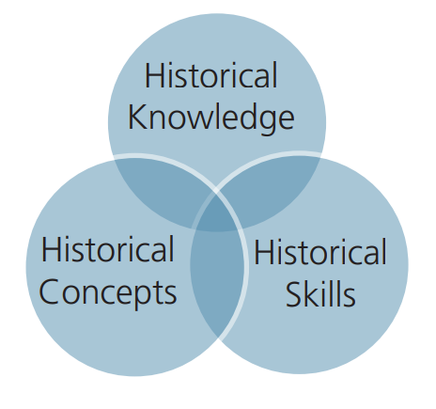

Year 1 | Changes in living memory: King Charles III | A local study – Ham House | Explorers of the sky
Year 2 | The Great Fire of London | Women in history | Explorers of the seas and skies
Year 3 | From Stone Age to Iron Age | Study of Ancient Egypt | The impact of the Romans on Britain
Year 4 | The study of Ancient Greece | The Anglo-Saxons arrival in Britain | The Vikings
Year 5 | The Ancient Kingdom of Benin | The Tudors (local study) | The History of the Technological Age and Business Enterprise
Year 6 | World War Two | The Victorians
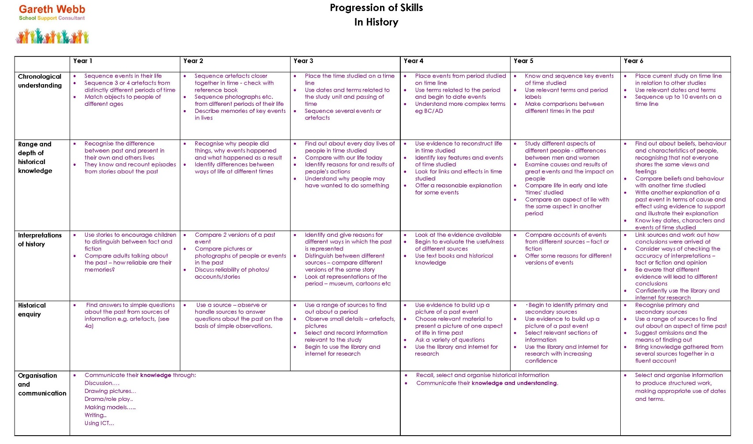
Progression of history skills

Spoken Language/Oracy
At Meadlands, we believe that speaking and listening form the foundations of good learning in History. In formal and informal situations, we create and encourage opportunities for meaningful conversation, discussion, and debate about learning. Questioning forms the basis of our teaching and we strongly encourage children to be curious and to share their thoughts confidently in a supportive environment. Through spoken language, children learn how other people make sense of the world, how language is sued to reason, how emotions and identities are expressed, and how to work together to solve problems.
What does speaking and listening look like at Meadlands?
Across the school:
- Listening to and participating in stories, articles, poems, rhymes and songs
- Use of sentence stems to scaffold oral responses in class
- Using the strategy Agree, Build, Challenge to guide respectful discussions
- Questioning across the curriculum
- Drawing links verbally across the curriculum
- Reciting and reading aloud
- Presenting in front of an audience
- Debating
- Group work and reporting back
- Using lollipop sticks for participation
- Talk partners

Planning
History is planned in units by class teachers and overseen by the subject leader. Planning takes the form of:
- Knowledge organiser – which outlines the knowledge and skills to be taught, the vocabulary, significant individuals, links forwards and backwards and ambitious outcomes.

- Mid-term plan – breaks down the number of lessons to be taught, the learning challenges, the lesson focus, key questions, key vocabulary, resources needed and a statement of what the children will have learnt by the end of the lesson.

- Lesson slides – the plan for the individual lesson with the learning challenge and relevant information. These will include vocabulary and key enquiry questions. Children should be encouraged to complete their learning journey after each lesson as a “plenary” exercise.

To assess learnt knowledge, all children complete a low stakes quiz, a month after the unit of history has finished. This is then stuck in at the back of their Topic book.

Culture Capital

Where possible, children will enhance their history learning with trips or workshops and visits from parents or knowledgeable individuals. It is expected that all classes go on 1 history trip per year.

Year Group | Trip
1 | Ham House
2 | Great Fire of London Workshop
3 | Petrie Museum – Ancient Egyptians  Chertsey Museum Stone Age Workshop
4 | Chertsey Museum Ancient Greek Workshop
5 | Hampton Court - Tudors  Chertsey Museum - Tudors
6 | Chertsey Museum

Cross curricular links

History is taught as a discrete subject, however, links across the curriculum should be made wherever possible. Opportunities for writing are documented in the yearly writing plan and teachers should think creatively about how vocabulary can be threaded through their teaching of history.

SMSC – History naturally relates to the teaching of spiritual, moral, social, and cultural development. Our mid-term plans encourage teachers to explore opportunities to ask higher level questions that encourage the children to think about their learning and what values and morals underlie them.

British Values – History also offers a unique opportunity to explore the very origins of British values, whilst also considering alternative value systems. Studying history allows children to understand and debate our values and learn about historical figures who fought for them.

Significant Individuals in History

It is important for children to investigate and celebrate the diversity of people who have shaped our history, those that have fought for our nation or for British values and how these significant individuals can make change happen. Many people have inspired us to follow our school motto and Dream Big.

Resources
A variety of history resources are available at Meadlands Primary and Nursery School. Amongst them are children’s reference books, photographs, and internet access and research tools. Resources are shared by all staff. When needed, additional resources are purchased by the History Co-ordinator in accordance with the school ordering policy and procedure. All staff may request or suggest resources they feel would be useful for a history topic.
Artefacts – History lessons should incorporate the use of artefacts for a “History Mystery” used as a hook to explore a central question or to consolidate learning. Many artefacts are stored in the History boxes in the science cupboard but can also be hired from The Chertsey Museum for short periods (see Appendix B for contact details).

IMPACT
- Children will know more, remember more, and understand more about history.
- Children will gain a love of history and a respect for the past.
- Children will understand and use the key skills of chronological understanding, knowledge and understanding of events in the past, historical interpretation, historical enquiry and organisation and communication.
- As historians, children will make connections with their own lives and learn lessons from history to influence the decisions they make in their lives in the future.

Assessment
There is no statutory history end of key stage assessment at Key Stage 2, but there is a statutory regulation to report to parents at least once a year about their child’s progress. Staff use their professional judgement in gathering of evidence of the child’s work, through written and practical work carried out through the year. This, coupled with the aims from the National Curriculum help teachers to form final reports at the end of the academic year.
Formative assessment occurs each day, in situations arising from written work, oral discussions and group activities.
A summative low stakes quiz also supports teachers in assessing what knowledge has been retained. These are created by the teacher and link directly to the key knowledge listed on the Knowledge Organisers.

Equal Opportunity
At Meadlands, all pupils, irrespective of their faith background are encouraged to take a full and active part in all history lessons and activities. Furthermore, all teaching and non-teaching staff should ensure that all pupils, irrespective of gender, ability, ethnicity, and social circumstances, have access to, and make the greatest progress possible, in all areas of the curriculum. There are opportunities for all able pupils to develop and extend their understanding of the different topics and themes.
Special Educational Needs
Children with special educational needs are taught the full history curriculum which is tailored by their teacher to meet their needs. Some children may receive additional support to help them take a full and active role in history lessons. More able pupils will be given relevant opportunities and challenges in class to extend their understanding, and to take part in appropriate extra-curricular activities. Furthermore, tasks and resources will be adapted if necessary, to help children succeed in reaching their potential.

Monitoring
History is monitored by the History subject leader and overseen by the school Curriculum Lead.

APPENDIX A

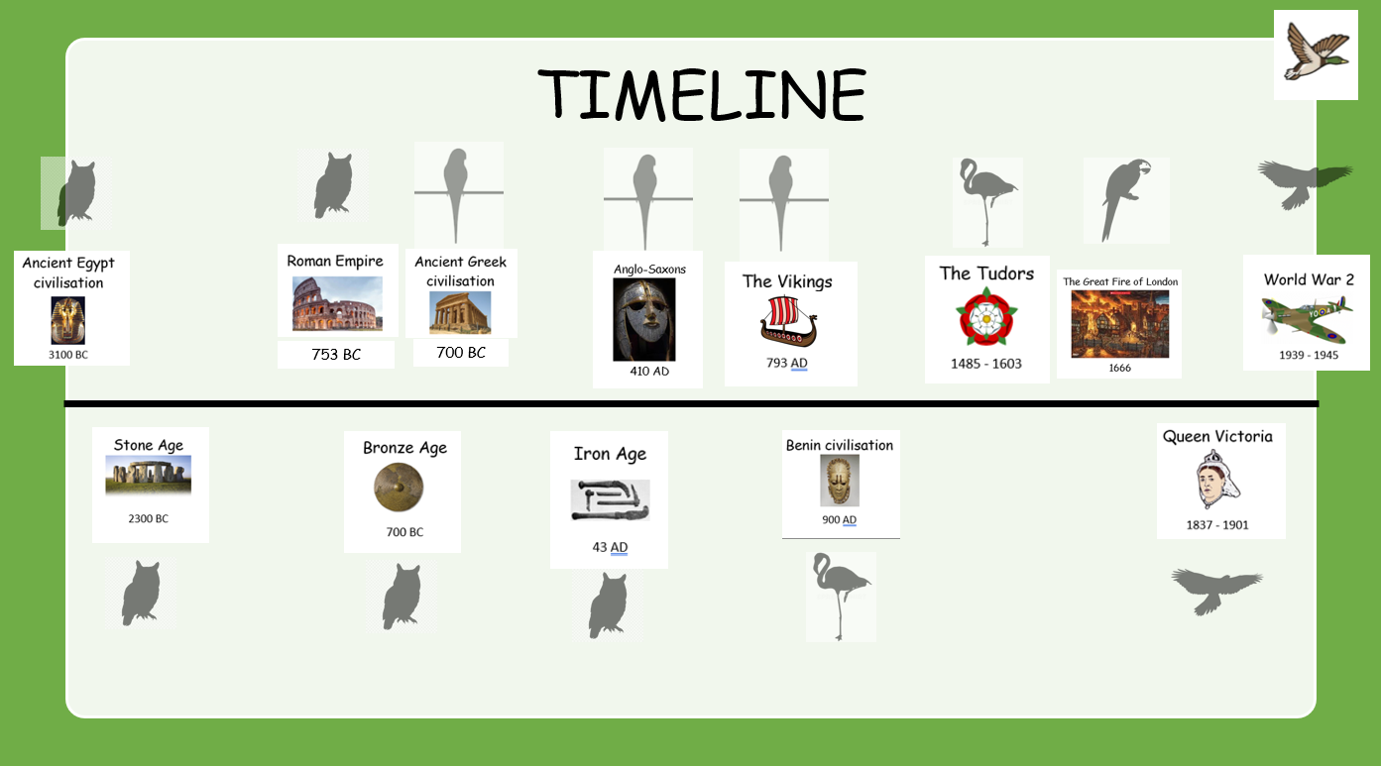

APPENDIX B

Useful websites:
The History Association https://www.history.org.uk/
The Chertsey Museum https://chertseymuseum.org/home
The Museum of London https://www.museumoflondon.org.uk/museum-london
The British library https://www.bl.uk/childrens-books
English Heritage https://www.english-heritage.org.uk/
Ashmolean Museum https://www.ashmolean.org/learning-resources
Layers of London https://www.layersoflondon.org/
Key Stage History https://www.keystagehistory.co.uk/

Artefacts: https://www.tts-group.co.uk/primary/history/historical-artefacts/ http://www.starbeck.com/
http://artefactstoorder.co.uk/
https://junipereducation.org/education-resources-service/artefact-loan-boxes/

APPENDIX C


