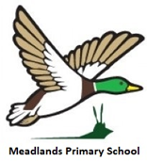

Autumn 1 Issue 1: 12th September 2025

Meadlands Primary School
Mallard Messenger

Our current school value is Motivation:



Date | Event | Applicable to
15.9.25 | Swimming – Week 1 | Year 6
18.9.25 | London’s Burning Workshop in school | Year 2
18.9.25 | Meet the teacher event. 3.30-5pm | All
22.9.25 | Swimming – Week 2 | Year 6

Page 2  Headteacher’s Update and Staff Corner | Page 3  Safeguarding  Parent  Events | Page 4  School Successes and Celebrations | Page 6  Attendance & School  Celebrations | Page 7  Class Updates | Page 11  Notice Boards


Headteacher’s Update

Autumn 1 Issue 1: 12th September 2025

Dear Parents and Carers,
A warm welcome back to the Autumn term! The children have come back revitalised and ready to learn. We are very excited about our upcoming Meet the Teacher and welcome BBQ, taking place next Thursday from 3.30 – 5.00. At 3.30, teachers will give a presentation in the classroom and parents will be free to look through their child’s books. This will be followed by a visit from the worshipful, the Mayor of Richmond-on Thames, counsellor Penny Frost, who will officially “open” our new mural in the playground. The mural (pictured below – it looks much better in the flesh!) was created by artist Ali and completed by every child in the school – something to brighten up our playground and to be cherished for years to come. Thank you to Tara, who instigated the project and as ever, Don and Richard, who put it all up. After the mural unveiling, there will be a BBQ – we will be selling hot dogs and crisps, and the drinks will be free. We hope to see as many of you there as possible.

Something very exciting happened over the summer holiday – our staffroom got a complete makeover! In true DIY SOS style, a group of parents led this project and as a result, we have a shiny new space! See the before and after pictures below. On behalf of all the staff, I would like to thank everyone who was part of this project and everyone who donated money towards this. In particular, I’d like to thank the project team: Sarah M, Robert M, Laura B, Komal P, Rebecca P, Christina P. You all went over and above to make this space workable and pleasant for us. It is so much appreciated!
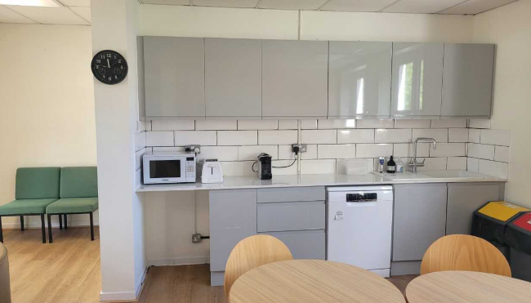
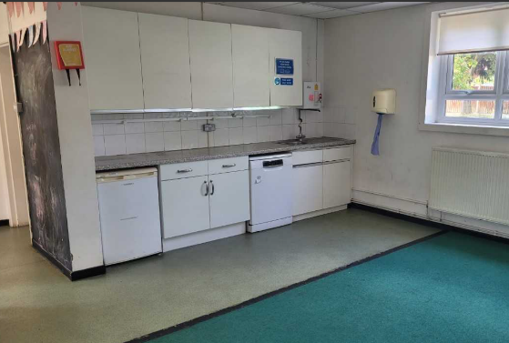
Before

After


Finally, I’d like to draw your attention to the wonderful family support service that has recently been set up. We have a dedicated family support worker: Cacherel Jules. She works at Meadlands every Monday and can support with a huge range of issues from anxiety, school refusal, behaviour issues at home, housing and lots more beside. There will be a drop in session for parents on Monday 29th September from 9-11am. If you would like a 20 minute appointment, please use the email cjules@darell.richmond.sch.uk or contact the school office.
I wish you all a wonderful weekend and hope to see you at the Welcome BBQ on Thursday.
Best wishes,
Mrs Wreford

Safeguarding & Wellbeing

Autumn 1 Issue 1: 12th September 2025

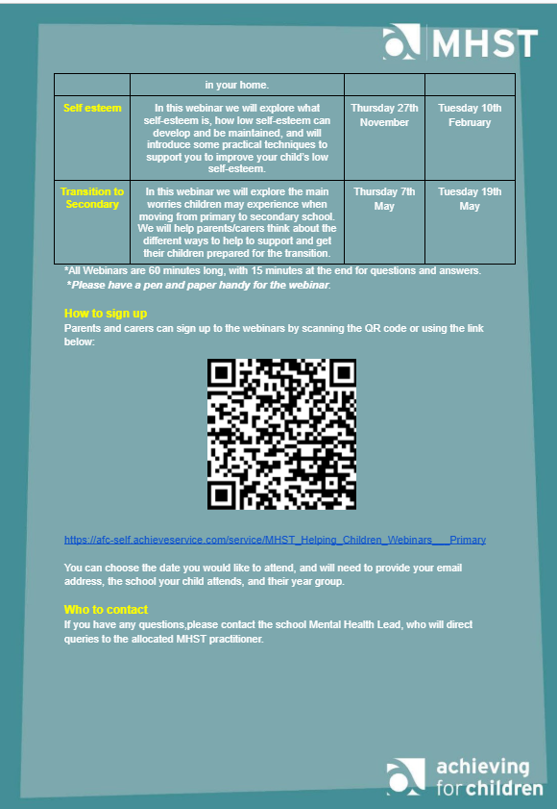
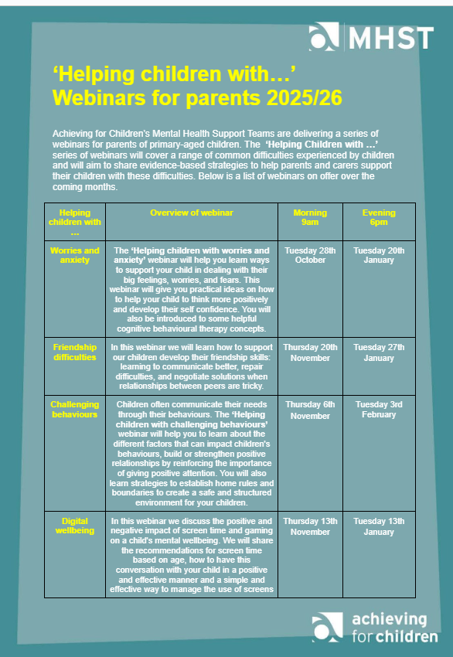
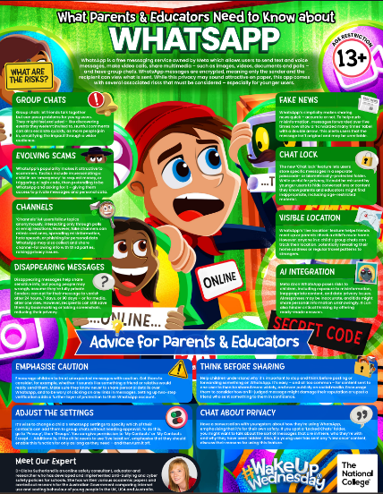
Please see on our website the updated poster for WhatsApp use https://www.meadlands.richmond.sch.uk/online-safety-1/
This warns against the potential risks associated with the new meta AI function, which cannot be turned off. To mitigate this new risk, parents are advised to block WhatsApp on children’s phones - if they need a messenger, only allow apps without AI chatbots built in. Our recommendation is https://signal.org which offers just messages, calls and nothing else.

School Success
and Celebrations
Achievement Certificate Winners:
Issue 5: 22nd March 2024
Well done to the following children for being awarded an achievement certificate.

Issue 8: 17th May 2024

Autumn Issue 2: 27th September 2024

Autumn Issue 1: 13th September 2024

Autumn 1 Issue 1: 12th September 2025

Year Group | Certificates awarded  Friday 12th September 2025
Year Group | Pupil of the week | Challenge | Motivation | Other certificates
Nursery |  | Dany | Sophie
Reception |  | Anaya | Cayden
Year 1 | Eva | Otis | Nina
Year 2 |  | Pippa | Roma
Year 3 | Elliott | Charlotte | Nico & Filip
Year 4 | Gregor | James | Harper & Bodhi
Year 5 | Lisbeth | Oscar & Paddy | Sawyer
Year 6 |  | Yu Chi | Miles

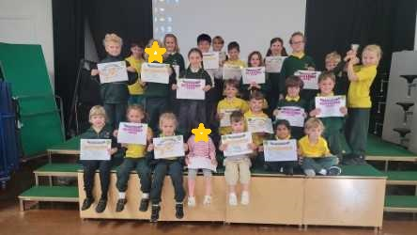

Year Group | Certificates awarded  Friday 5th September 2025
Year Group | Pupil of the week | Challenge | Motivation | Other certificates
Nursery | NOT | STARTED | YET
Reception | NOT | STARTED | YET
Year 1 |  | Freddie | Khadija & Edward
Year 2 |  | Jude | Ky
Year 3 |  | Mia | Mela
Year 4 |  | Carter | Theo
Year 5 |  | Isabella & Teddy | Denis & Ella
Year 6 |  | Hattie | Aidan

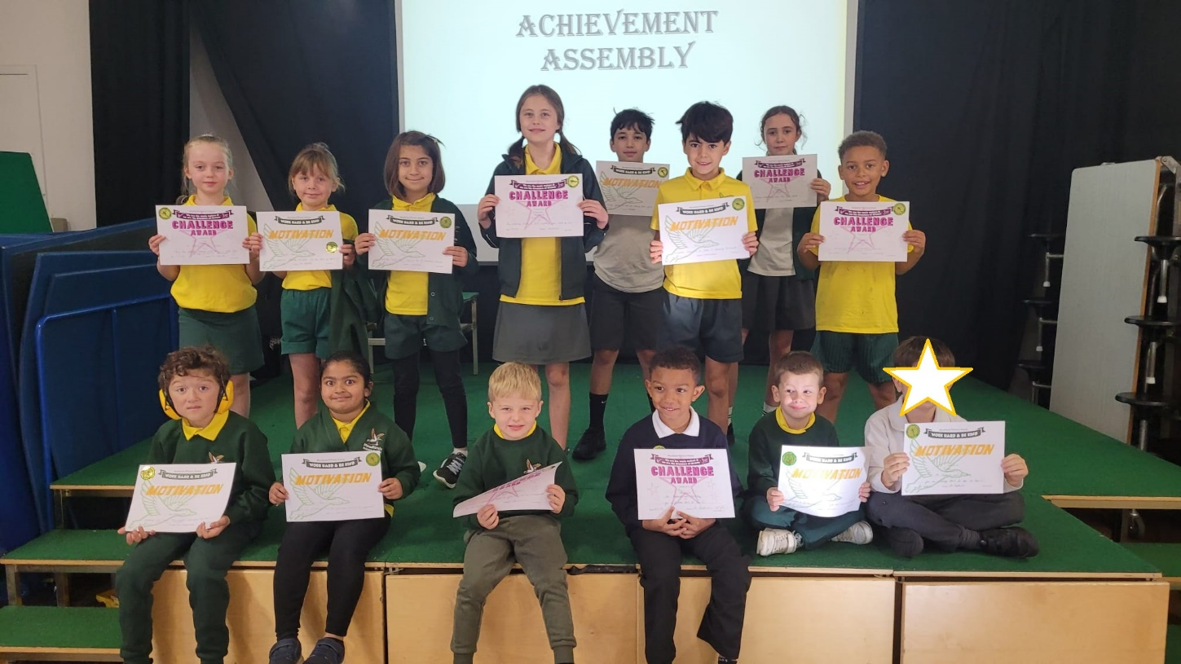



Autumn 1 Issue 1: 12th September 2025

Issue 12: 19th July 2024

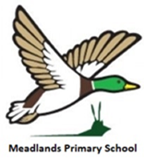
Attendance & Celebrations:

Autumn 1 Issue 1: 12th September 2025

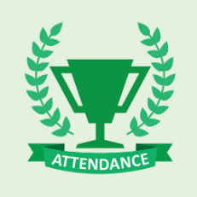

Week ending 12.9.25 - Well done to Year 1 for winning the attendance trophy and achieving an attendance of 98.6% this week.
Week ending 5.9.25 - Well done to Year 2 for winning the attendance trophy and achieving an attendance of 98.8% last week.



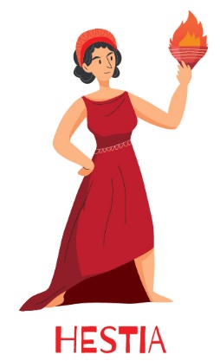
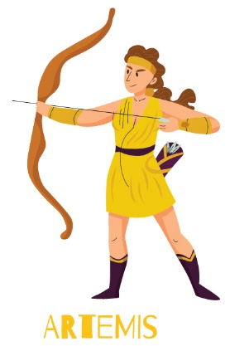

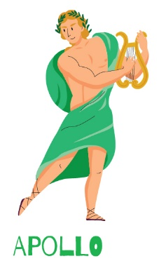

127
145
111
221

Class Updates
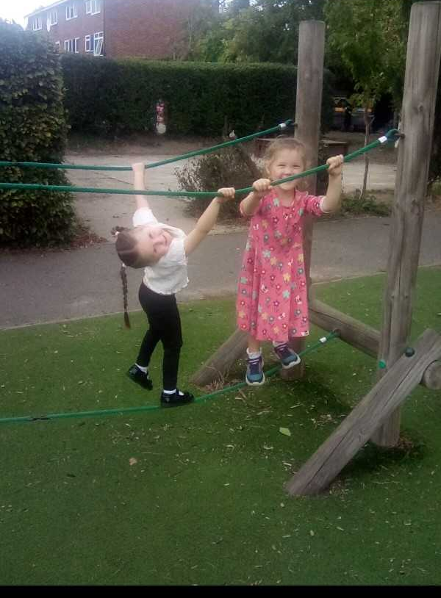
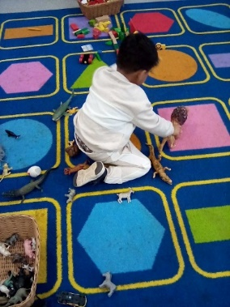
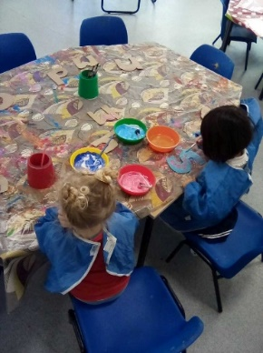

Autumn 1 Issue 1: 12th September 2025

Look at what Nursery have been learning…
This week we have been getting to know each other and the classroom. We have played with lots of different toys, done some beautiful art work and made lots of new friends!
The children have really settled into nursery life, it’s lovely to watch them explore the classroom and get used to their new routines. I know we are going to have lots of fun this year!
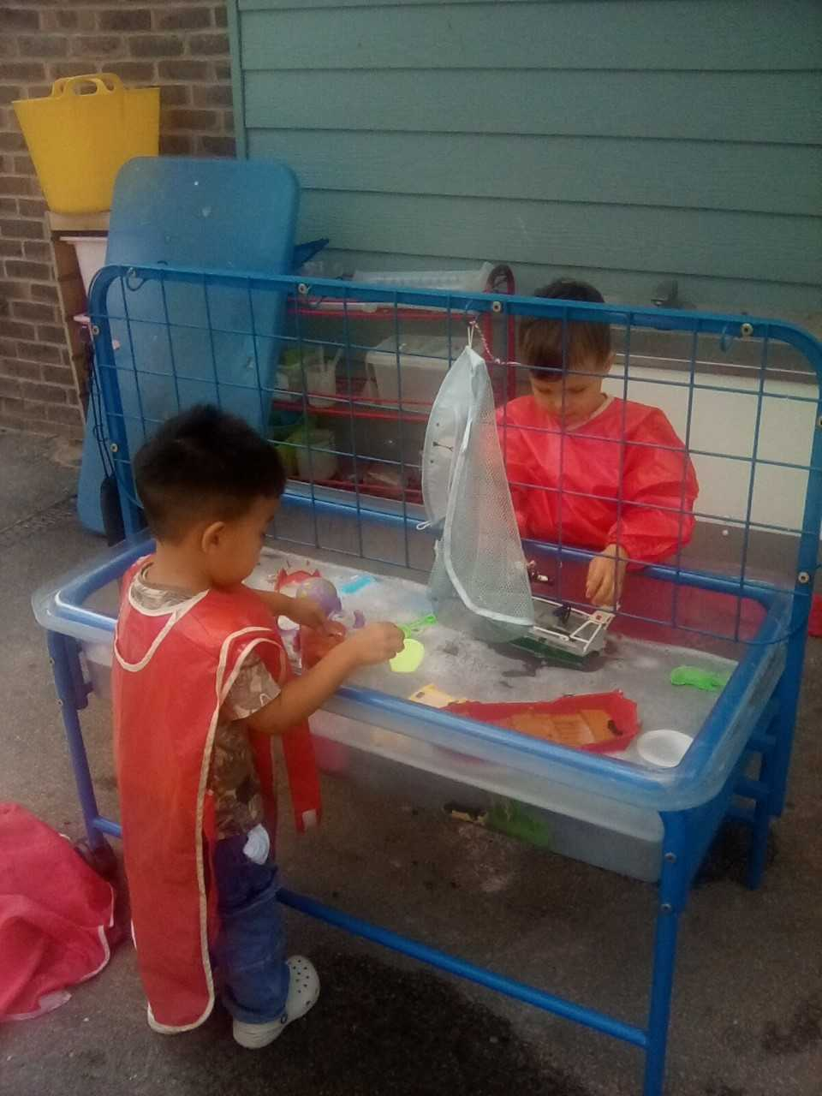

Look at what Reception have been learning…
The new Puffins have arrived! They have spent their first week diving straight into our first topic, ‘I am super’. They have dressed up as different superheros, demonstrating their best superhero poses, and have made their own superhero masks. We are very proud of how brave and grown up they have been, taking on the challenges of starting Reception head first.

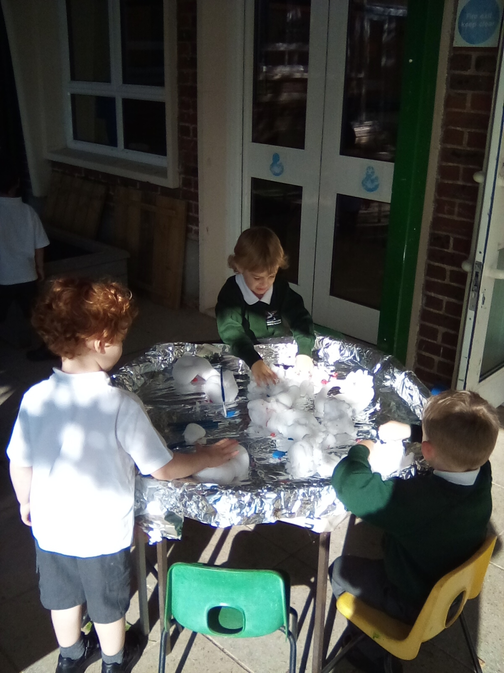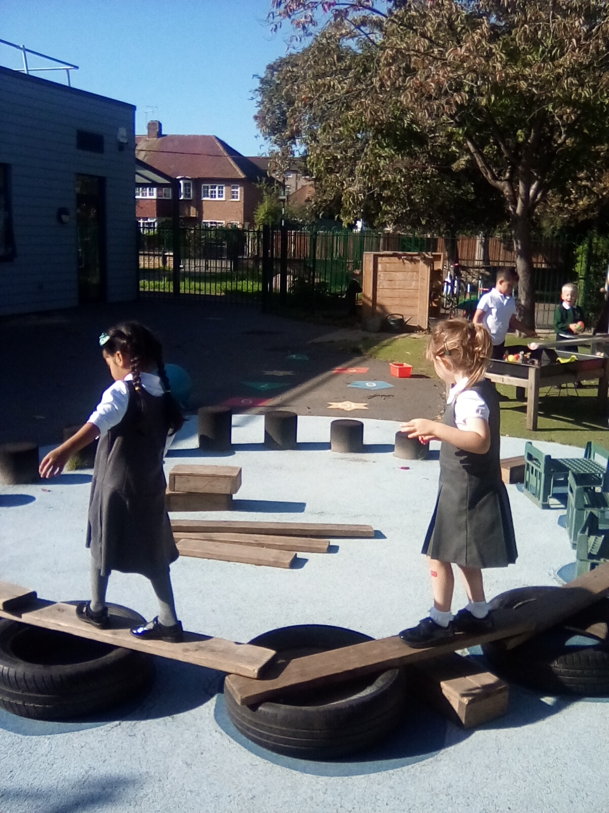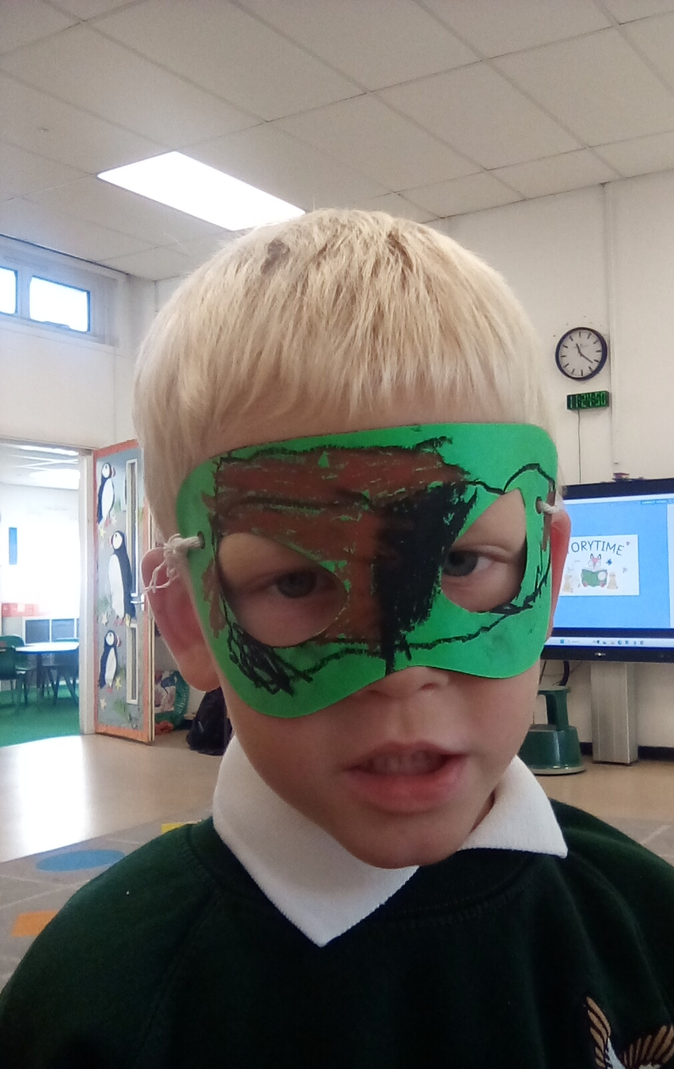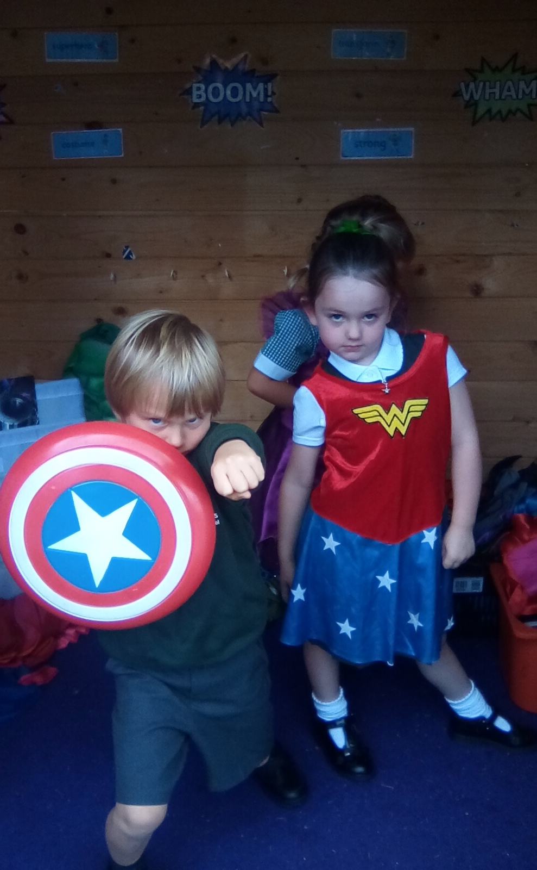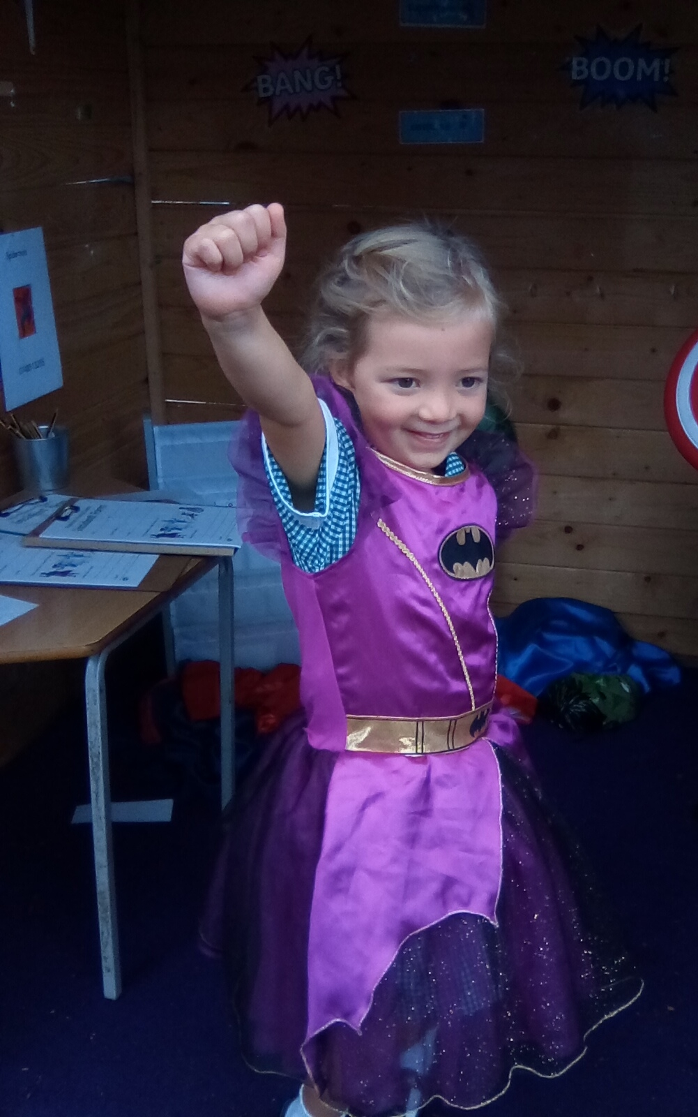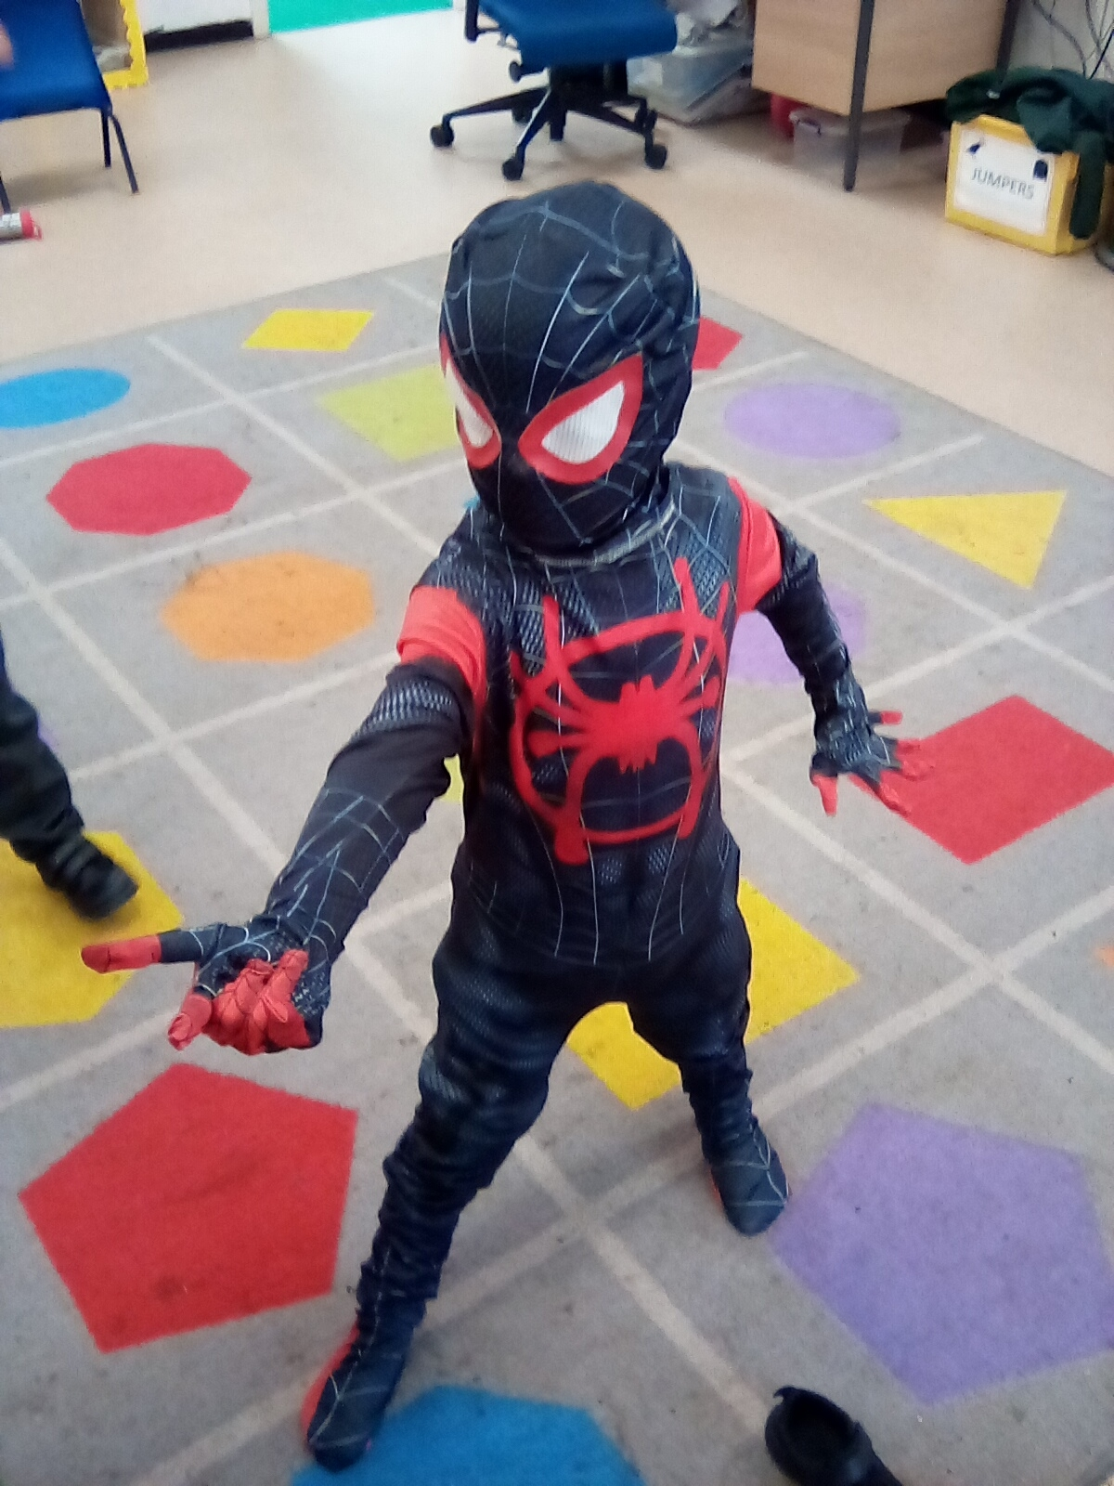

Class Updates

Spring Issue 4: 7th March 2025

Look at what Year 1 have been learning…
We are so proud of how well the children have settled into Penguin Class. They have been highly engaged in their learning and have enjoyed starting new subjects such as History, Art, and Computing. In Science we have been exploring the seasons and looking at different types of weather. Well done on a fantastic first full week Year 1!
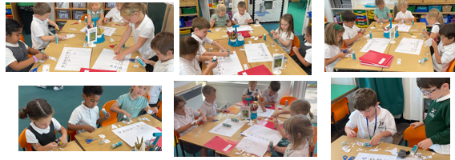
Look at what Year 2 have been learning…
This week, the scarlet macaws have been learning all about…Scarlet Macaws! They have been writing amazing sentences all about what scarlet macaws look like, what they eat and where they live. They have also done some absolutely amazing oral presentations, where they told each other all the facts that they learnt. They used loud, clear and confident voices, and expressed themselves very well!
Well done Year 2!

Spring Issue 3: 14th February 2025

Autumn 1 Issue 1: 12th September 2025

Class Updates

Look at what Year 3 have been learning…
Year 3 have made an excellent start to life as Snowy Owls! We have started our work on the Stone Age both in History and English as well as studying rocks, fossils and soils in Science. I guess you could say our Year 3 work rocks!
In Art, we have started a unit all about the works of Japanese artist Yayoi Kusama. We have responded to multiple pieces of her work with Pumpkin proving to be a favourite. We will be attempting live drawings of gourds next week before eventually sculpting our own out of clay!
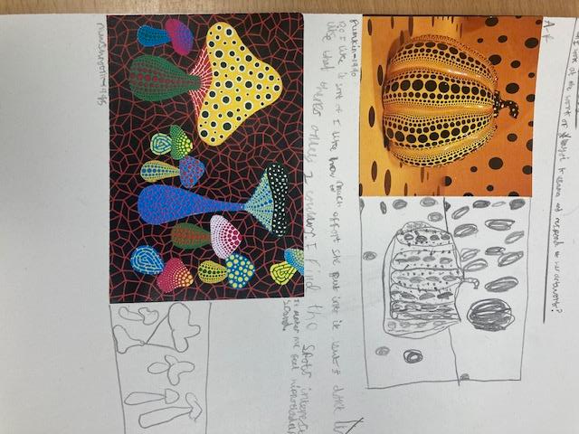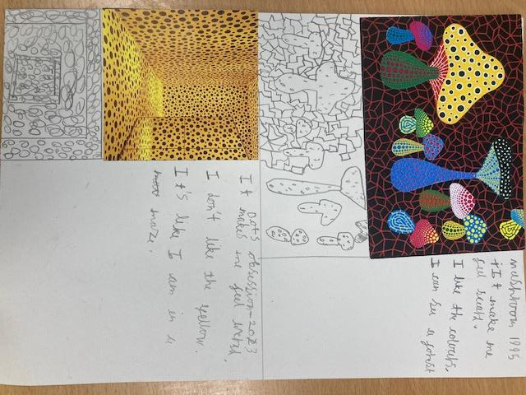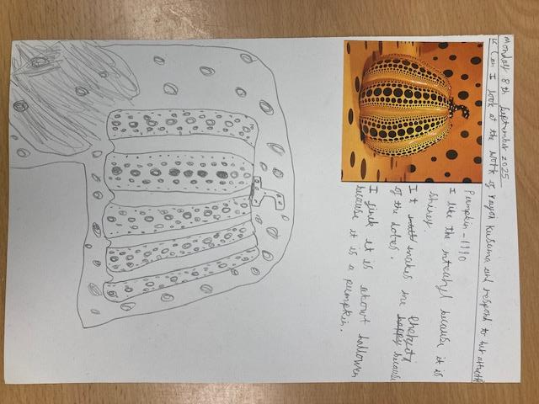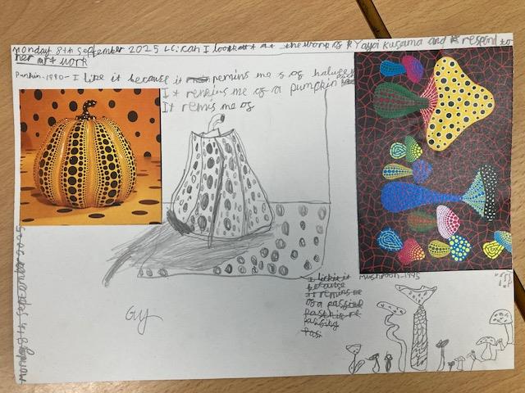

Issue 5: 22nd March 2024
Look at what Year 4 have been learning…
Year 4 has started off the school year so well with positive attitudes to learning and commitment to the quality of their work. We have begun our unit about Ancient Greece by studying different Greek myths in Reading lessons and focusing on the myth of Medusa and Perseus in our English writing. In history, we have begun our studies by looking at where the Ancient Greeks fit in the timeline and comparing the similarities and differences between the city-states of Athens and Sparta. We are focusing on Place Value in maths and have begun practising times tables. In Science, we have been learning about classification of Living Things.
I am looking forward to a fabulous year ahead with Year 4! Mrs H

Autumn Issue 2: 27th September 2024

Summer 2 Issue 3: 11th July 2025



Autumn Issue 2: 27th September 2024

Autumn Issue 2: 27th September 2024

Autumn 1 Issue 1: 12th September 2025

Class Updates
Look at what Year 5 have been learning…
Year 5 have made an absolutely super start to the year and have been impressing Mrs Holroyd and I with their excellent writing and brilliant questions.
In English, they have been practising using expanded noun phrases and direct speech in preparation of writing their own fables, having looked at some of Aesop’s and discussing their key features and morals.
In History, we have started learning about The Kingdom of Benin and explored the chronology of the Kingdom and compared this to what was happening in Britain at the time.
In Science, we have been learning about reproduction of plants and looking at the parts of a flower and how they help the plant to make new plants.
We have also started learning about David Hockney and looking at Patterns in Landscapes in Art, so hopefully some beautiful artwork will follow in our next update!
Look at what Year 6 have been learning…

Year 6 have had a great start to the year! We have been really impressed with their attitude towards their learning and their maturity.
In English, they have been using personification to describe different things and looking at different word classes.
In History, we have began to look at World War 2, exploring how and why it started, as well as what would happen if different events had not occurred.
Our Art unit is optical illusions which has been a great hit! They have looked at different illusions, (some of which did make our eyes feel a bit weird), and are working on building their skills to create their own!

Meadlands Noticeboard

Autumn 1 Issue 1: 12th September 2025

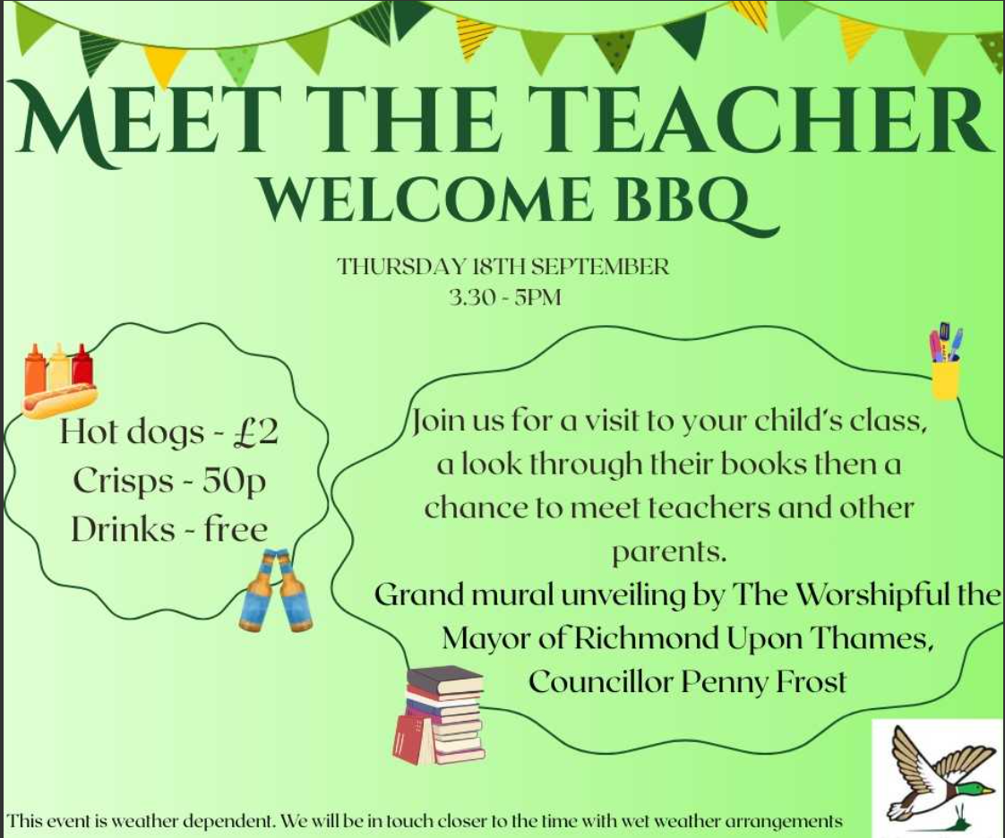

Safeguarding concern?

Are you concerned about the safety or welfare of a child? Please contact the SPA (Single Point of Access). Phone 020 8547 5008. You can make an online referral here.
If you think a child is in immediate danger you should call 999.

DISMOUNT FROM BIKES, SCOOTERS & SKATEBOARDS

Please can you remind children that they must dismount from bikes, skateboards and scooters at any of the small gates at the entrances to the school grounds. They are NOT to scoot or cycle through the carpark or beyond these entrances. This includes early children attending for clubs and boosters.




Community Noticeboard

Summer Issue 1: 2nd May 2025

Autumn 1 Issue 1: 12th September 2025

Autumn Issue 2: 27th September 2024

Autumn Issue 4: 25th October 2024

Autumn Issue 5: 15th November 2024

Issue 11: 5th July 2024

Issue 6: 19th April 2024

Issue 12: 19th July 2024

Autumn Issue 2: 27th September 2024

Autumn Issue 4: 25th October 2024

Autumn Issue 5: 15th November 2024

Autumn Issue 3: 11th October 2024

Autumn Issue 6: 29th November 2024



