
Key Instant Recall Facts - Year 6 Spring Term 2
I can identify prime numbers up to 50
By the end of this half term, pupils should know the following facts. The aim is for them to recall these facts instantly.

A composite number is divisible by a number other than 1 or itself. The following numbers are examples of composite numbers
4, 6, 8, 9, 10, 12, 14, 15, 16, 18, 20, 22, 24, 25, 26, 27, 28, 30, 32, 34, 35, 36, 38, 39, 40, 42, 44, 45, 46, 48, 49, 50

A prime number is a number with no factors other than itself and one. Therefore prime numbers only have 2 factors. The following numbers are prime numbers below 20
2, 3, 5, 7, 11, 13, 17,19, 23, 27, 29, 31, 37, 41, 43, 47

Key Vocabulary:
Prime number
Composite number
Multiple = A multiple is a number that can be divided by another number a certain number of times without a remainder.
Factor = A factor is one of two or more numbers that divides a given number without a remainder.
Multiples and factors are best explained by using a number sentence such as the following:
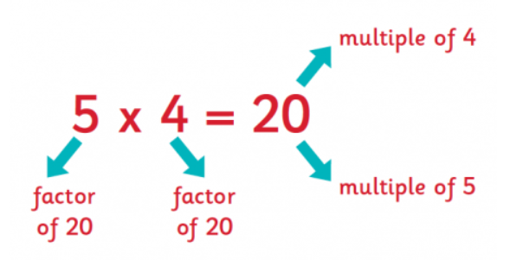

This number sentence tells us that 20 is a multiple of 5 and is also a multiple of 4.

It also tells us that 5 and 4 are factors of 20

Top Tips
The secret to success is practising little and often. Use time wisely. Can you practise these KIRFs while walking to school or during a car journey? You don’t need to practise them all at once: perhaps you could have a fact of the day. If you would like more ideas, please speak to your child’s teacher.

Activity ideas
It’s really important that your child uses mathematical vocabulary accurately, play games such as:

* Choose a number between 2 and 50.
How many correct statements can your child make about this number using the vocabulary above?

* Make a set of cards for the numbers from 2 to 50.
How quickly can your child sort these into prime and composite numbers?
How many even prime numbers can they find?
How many odd composite numbers?

