
Key Instant Recall Facts
Year 6 Spring Term 1
I can convert between decimals, fractions and percentages.

By the end of this half term, pupils should know the following facts. The aim is for them to recall these facts instantly.
Key Vocabulary:

Equivalent
Fractions
Decimal
Percentages
How many tenths is 0.8?
How many hundredths is 0.12? Write 0.75 as a fraction?
Write ¼ as a decimal?
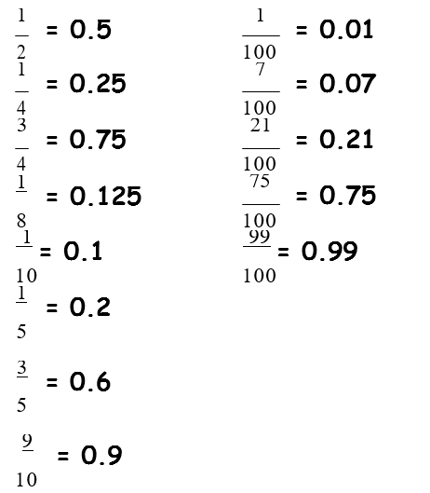

Key Imagery:
Prove using bar model:
 | Whole = 1
 | 0.1 | 0.1 | 0.1 | 0.1 | 0.1 | 0.1 | 0.1 | 0.1 | 0.1 | 0.1
part part part part part part part part part part

(Each part represents 1/10 of the whole)

Please see separate sheet for fraction and decimal wall.
Top Tips
The secret to success is practising little and often. Use time wisely. Can you practise these KIRFs while walking to school or during a car journey? You don’t need to practise them all at once: perhaps you could have a fact of the day. If you would like more ideas, please speak to your child’s teacher.
Activity ideas
Play games Make some cards with pairs of equivalent fractions and decimals or downloaded them from https://nrich.maths.org/1249 . Use these to play the memory game or snap. Or make your own dominoes with fractions on one side and decimals on the other.
Equivalent posters Using the bar model to make equivalent fraction, showing different decimals as a fraction, posters for tenths and hundredths.

