Key Instant Recall Facts - Year 6 Autumn Term 2
I can identify common factors of a pair of numbers.
By the end of this half term, pupils should know the following facts. The aim is for them to recall these facts instantly.
The factors of a number are all numbers which divide it with no remainder.
E.g. the factors of 24 are 1, 2, 3, 4, 6, 8, 12, and 24.
The factors of 56 are 1, 2, 4, 7, 8, 14, 28 and 56.

The common factors of two numbers are the factors they share.
E.g. the common factors of 30 and 24 are 1, 2, 3 and 6. The greatest common factor of 30 and 24 is 6.
Key Vocabulary:
Factor
Common factor
Greatest common factor
Multiple
What are the common factors of 144 and 56?
Which number between 20 and 40 has the greatest number of factors?

Children should be able to explain how they know that a number is a common factor.
E.g. 8 is a common factor of 24 and 56 because 24 = 8 × 3 and 56 = 8 × 7.

Top Tips
The secret to success is practising little and often. Use time wisely. Can you practise these KIRFs while walking to school or during a car journey? You don’t need to practise them all at once: perhaps you could have a fact of the day. If you would like more ideas, please speak to your child’s teacher.
Activity ideas
- Choose two numbers Take it in turns to name factors. Who can find the most?
- Play games There are many interactive games that can be played to help develop instant recall, here are a few links to try: http://www.conkermaths.org/cmweb.nsf/products/conkerkirfs.html (Factor Pairs tab)
- http://www.fun4thebrain.com/beyondfacts/gcfsketch.html (greatest common factor game)
- https://www.topmarks.co.uk/Search.aspx?q=factors

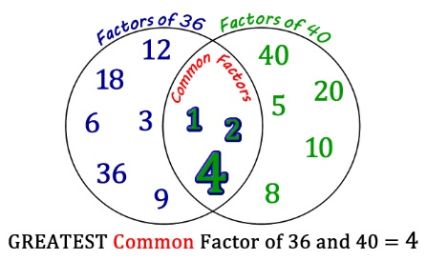
- Create a Venn diagram Write factors for 2 numbers on post-it notes and then add to a Venn diagram to find the common factors.

