Key Instant Recall Facts - Year 5 Autumn Term 1
I know the multiplication and division facts for all times tables up to 12 × 12.
By the end of this half term, pupils should know the following facts. The aim is for them to recall these facts instantly.
Please see the attached for all the times table facts
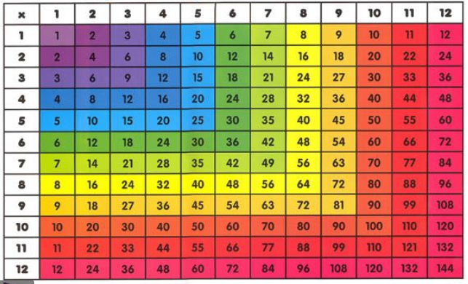
Key Vocabulary:
What is 12 multiplied by 6?
What is 7 times 8?
What is 84 divided by 7?
How many 8s in 56?
What is the product of 9 and 6?

Top Tips
The secret to success is practising little and often. Use time wisely. Can you practise these KIRFs while walking to school or during a car journey? You don’t need to practise them all at once: perhaps you could have a fact of the day. If you would like more ideas, please speak to your child’s teacher.

The attached list includes some examples of facts that children should know
They should be able to answer these questions in any order, including missing number questions
e.g. 7 x  = 28 or  ÷ 6 = 7.

Activity ideas
- Songs and Chants You can find times table songs on Youtube.
- Speed Challenge Take two packs of playing cards and remove the kings. Turn over two cards and ask your child to multiply the numbers together (Ace = 1, Jack = 11, Queen = 12). How many questions can they answer correctly in 2 minutes? Practise regularly and see if they can beat their high score.
- Online games There are many games online which can help children rehearse their multiplication and division facts. http://www.conkermaths.org/cmweb.nsf/products/conkerkirfs.html (Multiplication tab)
- Tablemaster http://www.transum.org/Software/Tablesmaster/
- Hit the button https://www.topmarks.co.uk/maths-games/hit-the-button
- Make a poster Record the fact families for each multiplication times table, for example
7 x 10 = 70  10 x 7 = 70  70 ÷ 7 = 10  70 ÷ 10 = 7 | To make it harder try removing some of the parts | 7 x __ = 70  __ x 7 = 70  __ ÷ 7 = 10  70 ÷ __ = 7

