
Key Instant Recall Facts - Year 4 Spring Term 2
I can recognise decimal equivalents of fractions
By the end of this half term, pupils should know the following facts. The aim is for them to recall these facts instantly.
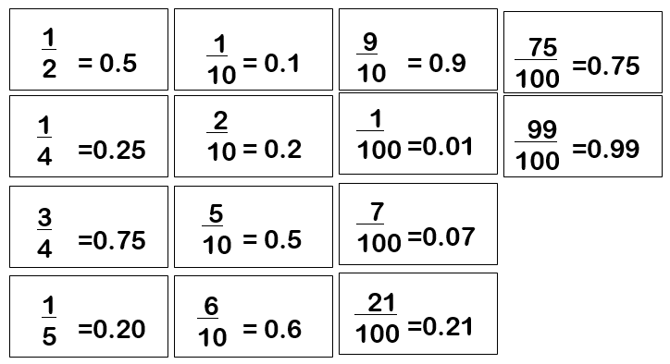
Key Vocabulary:
How many tenths is 0.8?
How many hundredths is 0.12? Write 0.75 as a fraction?
Write ¼ as a decimal?

Key Imagery:
Prove using bar model:
 | Whole = 1
 | 0.1 | 0.1 | 0.1 | 0.1 | 0.1 | 0.1 | 0.1 | 0.1 | 0.1 | 0.1
part part part part part part part part part part

(Each part represents 1/10 of the whole)
Children should be able to convert between decimals and fractions for ½, ¼, ¾ and any number of tenths and hundredths.

Top Tips
The secret to success is practising little and often. Use time wisely. Can you practise these KIRFs while walking to school or during a car journey? You don’t need to practise them all at once: perhaps you could have a fact of the day. If you would like more ideas, please speak to your child’s teacher.

Activity ideas
- Play games - Make some cards with pairs of equivalent fractions and decimals. Use these to play the memory game or snap. Or make your own dominoes with fractions on one side and decimals on the other.
- Equivalent posters- Using the bar model to make equivalent fraction, showing different decimals as a fraction, posters for tenths and hundredths.
- https://www.topmarks.co.uk/maths-games/daily10 – Level 5 and 6, fraction decimal games. Children are given ten mental questions to answer testing their understanding of fraction and decimal equivalence

