Key Instant Recall Facts - Year 3 Autumn Term 2
I the multiplication and division facts for the 3 times tables.
By the end of this half term, pupils should know the following facts. The aim is for them to recall these facts instantly.
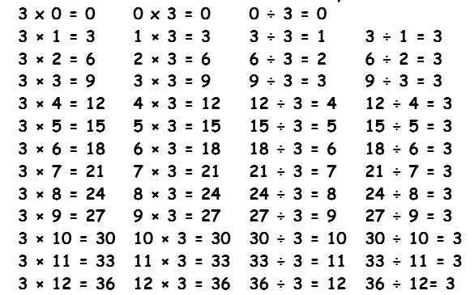
Key Vocabulary:

What is 3 multiplied by 7?
What is 3 times 9?
What is 12 divided by 3?
How many lots of 3 are in the number 12?
How many groups of 3 are there in the number 24?

Fact Families

They should be able to answer these questions in any order, including missing number questions e.g. 3 x? = 15 or ? ÷ 7 = 3.

Top tips
The secret to success is practising little and often. Use time wisely. Can you practise these KIRFs while walking to school or during a car journey? You don’t need to practise them all at once: perhaps you could have a fact of the day. If you would like more ideas, please speak to your child’s teacher.
Activity ideas
- Times Table Rockstar- Regular use of Times Table Rockstar helps to motivate children to learn times tables with varying degrees of success. https://ttrockstars.com/login
- www.conkermaths.org – click on the ‘balloons’ tab and then select the 3 times table tab to play.
- https://www.topmarks.co.uk/maths-games/hit-the-button
- https://www.transum.org/Software/Tablesmaster/ Complete 20 three times table questions and be given a completion time. Children can then repeat and try to beat their initial time.
- Use what you already know– If your child knows that 3 × 5 = 15, they can use this fact to work out that 3 × 6 = 15.

- Test the Parent– Your child can make up their own tricky division questions for you e.g. What is 27 divided by 3? They need to be able to multiply to create these questions.
- Play a game card. Take it in turns to pick a card from the deck, mutipy the value of
the card by 3. If the player gets the answer correct they get to keep the card, if
wrong they return it to the pack. The winner is the player with the most cards at the
end of the game

Warning! – When creating fact families, children sometimes get confused by the order of the numbers in the division number sentence. It is tempting to say that the biggest number goes first, but it is more helpful to say that the answer to the multiplication goes first or the whole number, as this will help your child more in later years when they study fractions, decimals and algebra.
E.g. 3 × 12 = 36. The answer to the multiplication is 36, so 36 ÷ 3 = 12 and 36 ÷ 12 = 3

