
Key Instant Recall Facts - Year 1 Autumn 2
I know the number bonds to 10
By the end of this half term, pupils should know the following facts. The aim is for them to recall these facts instantly.
Key Vocabulary:

What is 3 add 2?
What is 2 plus 2?
What is 5 take away 2?
What is 1 less than 4?
What is the whole?
What are the parts?

Fact Families
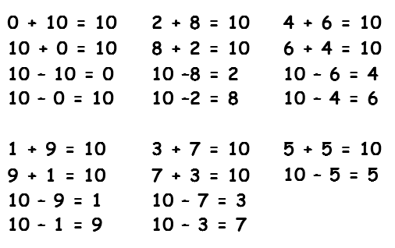

They should be able to answer these questions in any order, including missing number questions e.g.
8 + ? = 10 or 10 - ? = 8.

Top tips
The secret to success is practising little and often. Use time wisely. Can you practise these KIRFs while walking to school or during a car journey? You don’t need to practise them all at once: perhaps you could have a fact of the day. If you would like more ideas, please speak to your child’s teacher.
Activity ideas
- Use practical resources– Your child has one potato on their plate and you give them two more. Can they predict how many they will have now?
- Make a poster– We use Numicon at school. You can find pictures of the Numicon shapes here: bit.ly/NumiconPictures –your child could make a poster showing the different ways of making 10.
- Play games– You can play number bond pairs online at to http://www.conkermaths.org/cmweb.nsf/products/conkerkirfs.html (Number tab) and then see how many questions you can answer in just one minute.
- Hit the button – make number bonds by hitting the number bond pair https://www.topmarks.co.uk/maths-games/hit-the-button

